

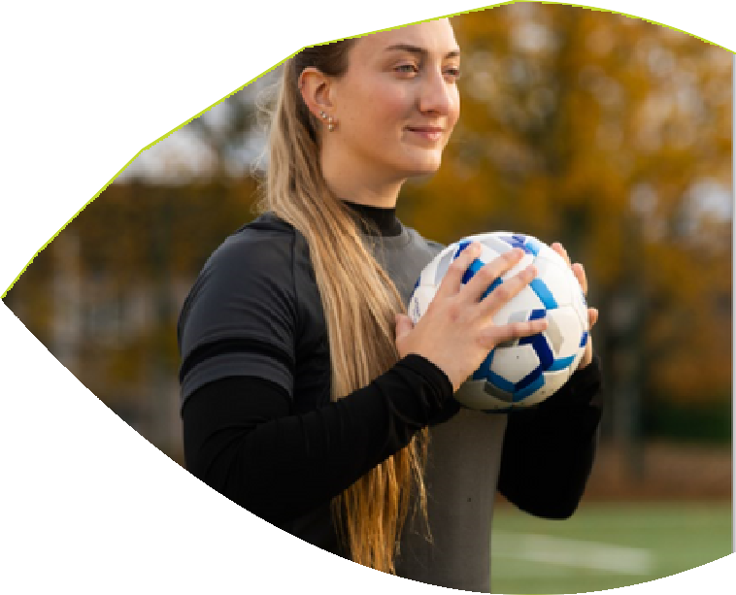
My name is Sam. I am 21 years old.

I was born with a cerebral visual impairment (CVI). CVI is a condition which means my eyes will track and follow things in my surroundings, but my visual pathways, from my eyes to my brain, do not work. This was caused by trauma during my Mum’s pregnancy and led to brain damage in the connecting pathways.

In 2014 my vision began to deteriorate leaving me severely sight impaired and I could no longer find my way round. I lost my ability to read and write which felt like losing a part of myself. I didn’t really understand my visual impairment and couldn’t explain it.
For many people sight loss can be so scary, lonely, and isolating. Every day activities become increasingly difficult, sometimes impossible, from getting around to making a cup of tea or cooking a meal.

My Mum knew about Sight Scotland and I began a flexible placement at the Royal Blind School. I split my schooling between mainstream school and the Royal Blind School where I was supported by the school's specialist team including Qualified Teachers of Children and Young People with Vision Impairment (QTVIs).

The Royal Blind School taught me independent living skills -things like cooking and how to go to the shops. They also showed me how to use my white cane, or Mr Pointy as I call him! He has become like a best friend; I couldn’t go anywhere without him!

Thanks to a wonderful teacher, Miss Young, I began to learn how to read and write in braille. That felt amazing, I felt like I had found the part of myself I lost when my sight began to worsen. I can now work with different technologies like BrailleNote Touch so I can type and use a computer.

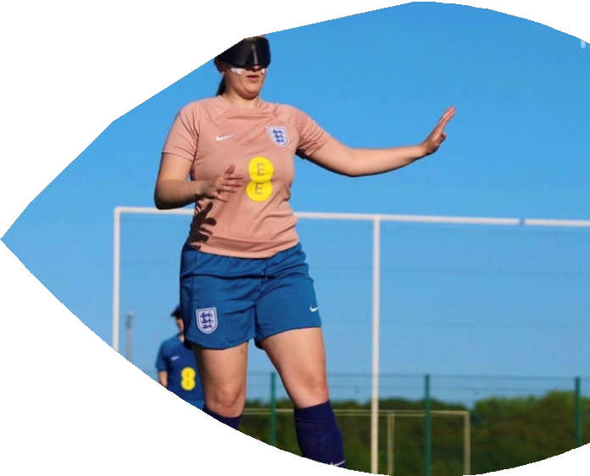
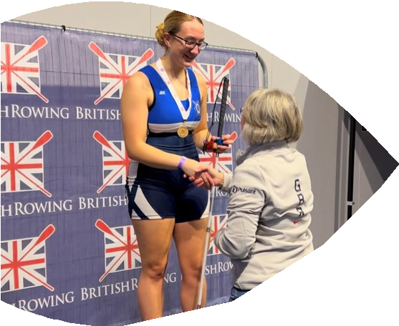

Most importantly it taught me how to accept myself with my disability and advocate for myself by saying what support I need.
.
Sight Scotland sees possibilities, not barriers, and by providing the right support helps people like me to achieve amazing things. The Royal Blind School was amazing for me, as I was given tailored specialist teaching and the opportunity to learn independent living skills.
I have the confidence to go out and try new things. Now I really push myself to be the best I can be. Having a visual impairment does make you different, but it's not a barrier to do the things you enjoy.
For me, this means sports. It wasn’t long ago that I didn’t think I could take part in sport at all. Being severely sight impaired excluded me from sport. Sight Scotland’s Royal Blind School changed this path for me. If you told me then what I would be doing now, I would never have believed you.
I am England Blind Women’s Football captain and played at the inaugural IBSA Women’s World Championship, I swim, I horse ride, play goalball, and recently won Bronze with Great Britain at the U19’s Para Youth Games. I am also on the pathway for Great Britain for rowing after being introduced to the sport by a teacher at the Royal Blind School.
Sport saved my life, but I wouldn’t have been able to do any of this without the help and support of Sight Scotland’s Royal Blind School. My ambition is to take part in the Paralympic games.
My journey wouldn’t have been possible without the help of donors like you and your regular support. Please give a gift today to help more young people like me make their ambitions a reality!

