The Bugle: Spring 2024

From Sight Scotland Veterans. Visit sightscotlandveterans.org.uk
Table of Contents
Upcoming events: 2
A word from Gillian McDonald, Director of Operations 6
Veterans’ Stories 9
Daily art challenge becomes a creative hobby for Glasgow veteran 9
Veterans take to the hills for winter skills course 19
Veterans tee up at TopGolf 26
Tips and Tricks: 27
An introduction to Smart Home technology 27
Introducing JAWS, the most popular computer screen-reading software 31
Get Involved 33
Join our 2024 trip to National Cenotaph in London for Remembrance Day. 33
Scottish Sight Loss Councils seeking participants who want to make a difference 34
Sight Scotland Veterans’ General Veterans Forum 37
Sight Scotland Veterans’ Updates 39
Our Policy team’s recent campaigns 39
Footnote: 44

Upcoming events:

Ongoing

Archery sessions at the Linburn Centre every Sunday
Every Sunday, a coach from Scottish Archers is running free sessions for people with visual impairment at our Linburn activity centre in West Lothian. Archery can be great fun and you are welcome to join. Note, please arrange your own transport and bring lunch, as the centre is not fully open. To attend, please RSVP by calling 0800 035 6409 and speak with our Sight Loss Information team.

Dates of archery sessions at the Linburn Centre:
- April: Every Sunday: 21 April, 28 April.
- May: Every Sunday: 5 May, 12 May, 19 May, 26 May.
- June: Every Sunday: 2 June, 9 June, 16 June, 23 June, 30 June.
- Time: Drop in anytime between 10 am and 4 pm.
- Location: Sight Scotland Veterans Linburn Centre, Louis Braille Avenue, Wilkieston EH27 8EJ
- RSVP: Call 0800 035 6409.

April

Veterans Sight Support Groups
You are invited to attend our Veteran Sight Support Groups! These groups are run by Sight Scotland Veterans and bring together veterans of the Armed Forces, such as yourself, who are experiencing sight loss. You can call our Sight Loss Information Line on 0800 035 6409 to find out the meeting venue in your nearest town.
- Fife (North East): Tues 9 April, from 1:30 pm to 3:30 pm.
- Kirkaldy: Wed 10 April, from 11:00 am to 12:30 pm.
- Hamilton: Thurs 11 April, from 11:00 am to 12:30 pm.
- Inverness: Mon 15 April, from 11:00 am to 1:00 pm.
- Dundee: Tues 16 April, from 1:30 pm to 3:30 pm.
- Moray, Elgin: Mon 22 April, from 11:00 am to 1:00 pm.
- Aberdeen: Tues 23 April, from 1:30 pm to 3:30 pm.
- Perth: Tues 23 April, from 10:00 am to 12:00 noon. Angus: Wed 24 April, 1:30 pm to 3:30 pm.
- Kilmarnock: Thurs 25 April, 1:30 pm to 3:00 pm.

May

Veterans Sight Support Groups
You are invited to attend our Veteran Sight Support Groups! These groups are run by Sight Scotland Veterans and bring together veterans of the Armed Forces, such as yourself, who are experiencing sight loss. You can call our Sight Loss Information Line on 0800 035 6409 to find out the meeting venue in each town.
- Fife (North East): Tues 7 May, from 1:30 pm–3:30 pm.
- Hamilton: Thurs 9 May, from 11:00 am to 12:30 pm.
- Dundee: Tues 14 May, from 1:30 pm to 3:30 pm.
- Dumfries: Wed 15 May, from 11:00 am to 1:00 pm.
- Inverness: Mon 20 May. Call 0800 035 6409 for the start time.
- Perth: Tues 21 May, from 11:00 am to 12:00 noon.
- Kirkcaldy: Wed 22 May, 11:00 am to 12:30 pm.
- Moray, Elgin: Mon 27 May, from 11:00 am to 1:00 pm.
- Angus: Wed 29 May, from 1:30 pm to 3:30 pm.
- Kilmarnock: Thurs 30 May, 1:30 pm to 3:00 pm.

June

Veterans Sight Support Groups
You are invited to attend our Veteran Sight Support Groups! These groups are run by Sight Scotland Veterans and bring together veterans of the Armed Forces, such as yourself, who are experiencing sight loss. You can call our Sight Loss Information Line on 0800 035 6409 to find out the meeting venue in each town.
- Fife (North East): Tues 4 June, from 1:30 pm to 3:30 pm.
- Dundee: Tues 11 June, from 1:30 pm to 3:30 pm.
- Hamilton: Thurs 13 June, from 11:00 am to 12:30 pm.
- Perth: Tues 18 June, from 10:00 am to 12:00 noon.
- Inverurie: Thurs 20 June, from 11:00 am to 12:30 pm.
- Inverness: Mon 24 June. Call 0800 035 6409 for the start time.
- Angus: Wed 26 June, from 1:30 pm to 3:30 pm.
- Dumfries: Wed 26 June, from 11:00 am to 1:00 pm.
- Kilmarnock: Thurs 27 June, 1:30 pm to 3:00 pm.

A word from Gillian McDonald, Director of Operations
Welcome to our Spring edition of The Bugle. The days are getting longer and warmer, and in this edition, we have information about many different activities you can get involved in.
First up, we chat with an Air Force veteran, Scott Boyle, who took up a new hobby drawing comics. Scott has also been to the Veteran Sight Support Groups in his local area, where he is meeting other veterans who are impacted by sight loss. Scott says talking to others has helped him adapt to his sight problems – learn about Scott on page 10.
We’ve also got tales of veterans with sight loss who are getting out and playing sports. Read on page 21 about the boost in confidence and sense of achievement veterans got while on a winter skills course and about golfing adventures on page 28.
We have a dedicated team who are finding ways to get people impacted by visual impairment involved in sports and activities. Don’t hesitate to call 0800 035 6409, and our team can find something for you.
Our Tips and Tricks section has articles on voice-activated technology on page 30 and on computer screen readers on page 33. You can read about a popular computer screen-reading software called JAWS, which thousands of people use on computers every day. This article is written by Amy, who has visual impairment and uses computers for work.
If you like discussions and projects, you could also become involved in advocating for people with visual impairment. We are seeking volunteers for our new Sight Loss Councils, which involve people from many different backgrounds, and also for our Sight Scotland Veterans General Veterans Forum. Both of these advocacy groups are welcoming newcomers – you can read more on pages 36 and 39. Finally, you can read an update from our policy team on page 41.
I hope you enjoy this edition. Remember, if you’d prefer to listen to these stories, you are able to request an audio version of this magazine. Just give us a call on 0800 035 6409 and we can send it to you on CD or on a plug-in USB stick.
Best wishes,
Gillian McDonald, Director of Operations Sight Scotland Veterans

Veterans’ Stories

Daily art challenge becomes a creative hobby for Glasgow veteran
By Robert Steven
Setting yourself a challenge is a great way to commit to something new and begin a new hobby. In October 2023, Air Force veteran Scott Boyle challenged himself to draw a sketch every single day of the month.
“By the end of October, I was worn out,” Scott laughed, “but, in January, the weather was stinking and I was sitting at home… and I just got drawing again. The ideas kept coming.”
Now, four months since ‘Ink-tober’, Scott is still drawing comics and has finished drawing more than 65 original comic strips.
Scott says: “My comic is called ‘Biscuit Bytes’, and it’s the adventures of four characters: a purple-coloured character called ‘The dot’, the red-coloured ‘Gerald’, blue-coloured ‘Biscuit’, and their playful dog pal, Elsie.”
The image shows the four characters, across four strips.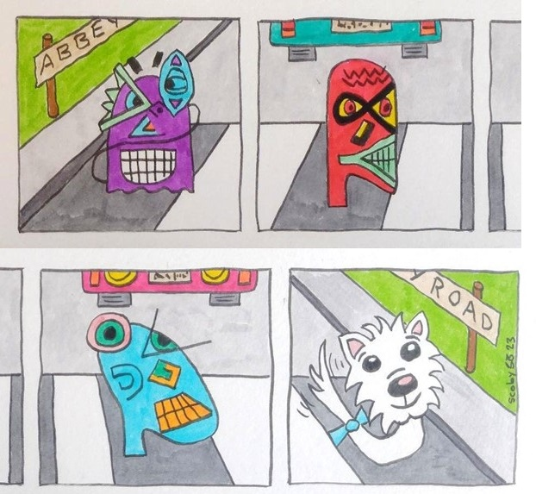
“Each comic strip has four boxes to tell the story. The stories are just little ideas in your life, observations you come across.”
Adventures in Scott’s comics include the four characters taking part in the Great British Bake-off, travelling to the moon, playing in a band, or going to the Winter Olympics. The comics can be found online, on Scott’s Instagram profile page at instagram.com/biscuitbytes1924.
Image caption: Picture of Scott at the Hawkhead activity centre art room. He is holding up a picture of Gerald that he has drawn and coloured.
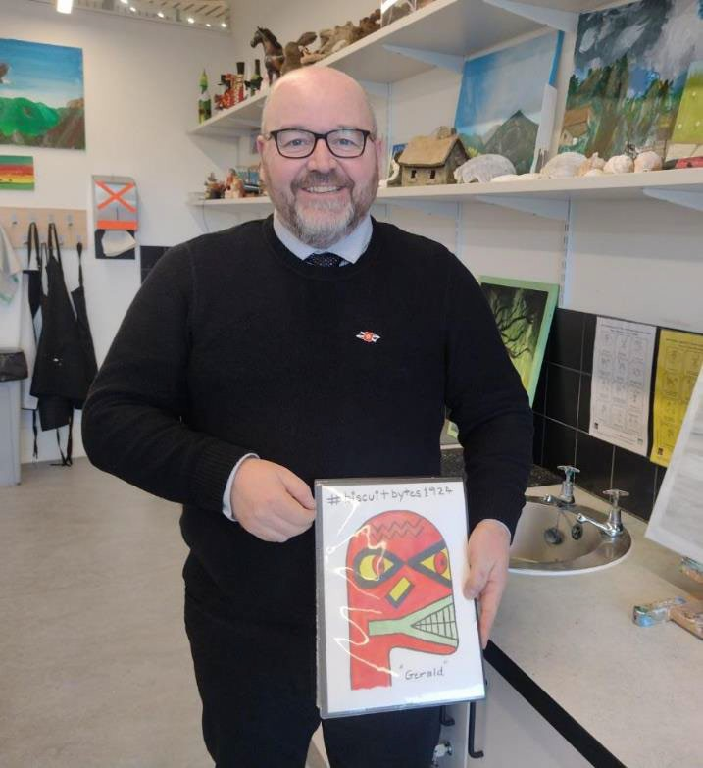

Scott’s experience of visual impairment
In several comic strips, Scott presents his experience of visual impairment. Since he had a stroke two years ago, Scott has had a large gap in his right-hand side peripheral vision. This gap is permanently filled by hallucinations, which is a phenomenon called Charles Bonnet Syndrome.
Scott said: “One of my Biscuit Bytes comics shows the four characters, but they are like a hall of mirrors because they're all distorted by Charles Bonnet Syndrome.”
The image is a comic trip showing the four characters, but there are distorted shapes and squiggly lines in the corners of the comic, replicating the impact that Charles Bonnet syndrome has on Scott’s sight.
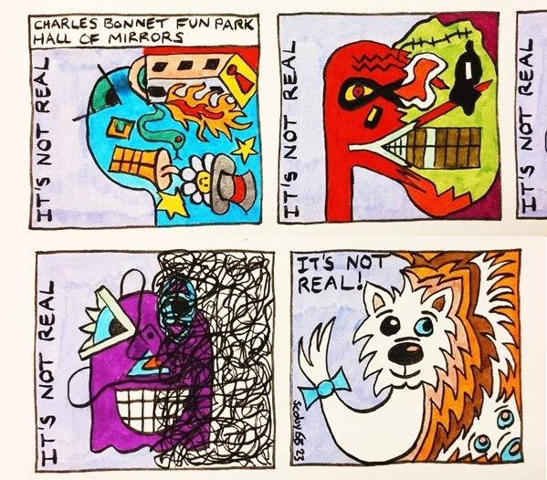
Scott said: “I can see straight ahead down the centre okay, but normally, at all times, my vision has squiggles and lines on the right-hand side where I don’t have any peripheral vision. It used to be as much as 45 degrees of my sight – a whole person could disappear from my sight in my peripheral vision. But it’s a little better now.”
Scott, who served in the Royal Air Force as a ground technician for 22 years, reckons his time in the military strengthened his determination to overcome challenges.
“When I had the stroke, everything got turned on its head. I felt my life was at rock bottom. You think you’re at the low ebb, but you know, you’ve been in the military, and we’ve got skills. You know it’s not as bad as that. You know you can get up again.”
Scott has learned to ignore the hallucinations and keep focused on the task at hand.
“Because I hallucinate in my right-hand side, I tend to turn my head, and my left eye faces down the centre of what I’m looking at. Then I can push my hallucinations out to the right and I don’t get disturbed by them when I’m trying to concentrate.
“I use my symbol cane to warn people there’s something not quite right with my vision.”
In addition to visiting the Hawkhead activity centre, Scott also attends a Veterans’ Sight Support Group, run by Sight Scotland Veterans.
“Every six weeks on a Thursday, there’s between six and eight of us veterans, meeting at a pub in Cumbernauld. We just have a bit of cake or scones, and just shoot the breeze.
“There’s no structure or anything – you just meet up and chat, and it’s a great way to keep in touch.”
Scott believes meeting other people impacted by vision loss has proved crucial.
“That’s definitely been a massive part of my rehabilitation. The way I’ve adapted to dealing with my sight loss is by talking to other people, and seeing how they adapt. If I was just in my own town, I don’t know anybody with sight problems, and I’d have no one to talk to about it.”

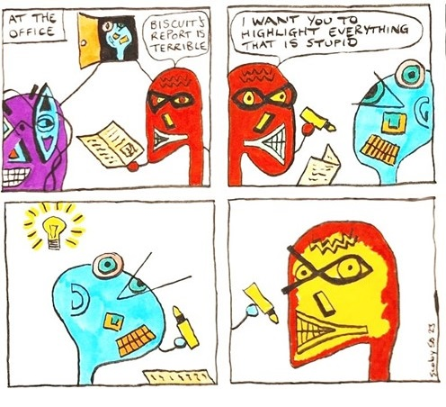
Comic shows a character, Gerald, holding up a paper report, saying that it’s terrible. Gerald asks the author of the report to review it again, and highlight “everything that is stupid”. The author of the report covers Gerald’s face with highlighter pen.

Military service
Scott served in the Air Force from the age of 18 to the age of 40.
“I was a ground technician in the service and maintenance of radar and radio,” Scott said. “I was attached to the Royal Air Force Regiment section, at RAF Lossiemouth. I was a Bowman Service Manager, so I controlled the functionality and the maintenance and repair of this new radio system the military was introducing, called Bowman, to replace the Clansman system.
We deployed the Bowman system in Iraq and Afghanistan and used it in Iraq and Afghanistan.
“Using Bowman, you can see where your troops are on the battlefield. You can’t see your enemy of course – they’re not sending you GPS! But you can mark where they are, from your troops’ reports.”
Scott progressed to the rank of sergeant and served in many territories, including the Falkland Islands.
“I’ve seen a lot of different places and many different things. Afghanistan and Iraq were not nice places, but I’ve also been to Alaska, the Falklands’, and the Himalayas. I was hiking and mountain biking in Alaska. There are really nice things you can do with the Forces.”
Scott said: “After 22 years, I needed a break. I went to Afghanistan for seven months, then back here for a year, before heading to Iraq for six months. When I got to the age of 40, I decided that my military career was coming to an end.”

New challenges
After leaving, Scott completed an HNC and an HND at a college, then did a degree in software development.
“The week after I left college, I joined a software development company in my hometown. I started building websites for the government, for HMRC.”
Scott worked in I.T. for six years. Unfortunately, he had a heart attack in 2016, and then a stroke in 2022, and he finished working.
“After I had the stroke, I didn’t want to leave the house,” he said.
Scott’s new challenge, since his stroke, has been reclaiming his independence and his social life.
“I got help from social workers and I got the travel card [the National Entitlement card]. I realised I needed to start building up my independence again, so I travel everywhere by bus now. I quite like the independence. I’m trying to learn how to cook again too.”
Getting out and chatting with others has lifted Scott’s mood too.
“I was never the best at small talk, but now I’m travelling and I am amongst people a lot more, and I’m always asking how people are and having a chat. I’ve found it very rewarding going to courses at the Glasgow School of Art. You’re meeting new people, and by the end of the ten weeks, you feel like you really get to know them.”

Want to learn more about Veterans Sight Support Groups that Scott Boyle talks about on page 13? Find out about the groups on page 4, and call 0800 035 6409.
- In Scotland, the National Entitlement Card (NEC) gives travellers with visual impairment free bus travel. Some privately owned ferries, premium airport buses and bus tours may not be included, however. If you don’t have an NEC card and you’d like information about applying for one, please get in touch with us on 0800 035 6409.

Veterans take to the hills for winter skills course
A group of veterans with visual impairment who recently went on a winter skills course in the Cairngorms came away from it with a great sense of achievement.
The veterans, who were apprehensive and nervous before the climb, said the trip ended up giving them a huge boost in confidence and independence.
The group included RAF veteran Iain Young, Army veteran Ian Hunter, and Steven Williams, who sustained his vision impairment during active service. The group journeyed to Glenmore Lodge in Aviemore.
The course was organised by Able2Adventure, a company which believes in the long-term benefits that participation in outdoor activities can have on people’s physical and mental health.
Through adventurous activities, people who have a disability can strengthen muscles, build balance and coordination, develop social networks, as well as increase their confidence and independence.
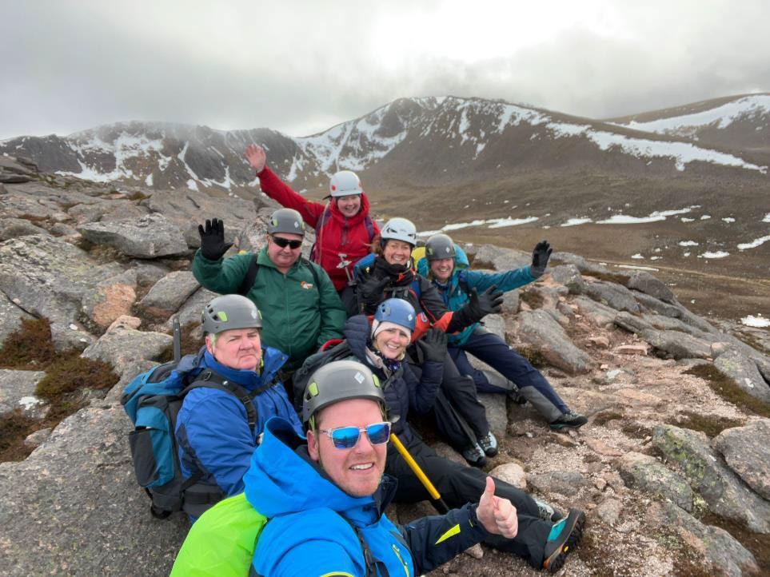
Caption: Image shows veterans and guides sitting down after climbing a mountain. There is snow on the mountain ridge.
Steven Williams said the course taught and built on skills: “The first day we were climbing the hill, using ice axes, crampons and learning new techniques to walk in deep snow. The second day was more about navigating and learning about our surroundings. We all had experiences of this during our time in the Armed Forces and Able2Adventure were constantly adding challenges to push us on. It really was a very inspirational and empowering trip.”
Iain Young, who has a visual impairment condition called Stargardt syndrome, said: “We all travelled up with quite a lot of trepidation as we were unsure whether we were capable of doing the course: both physically and due to our visual impairments. When we arrived at the lodge, we were fitted with our equipment and were talked through what to expect the following day. I was really worried I wouldn’t be able to do it as I have long Covid. But I was reassured to give it a go.
“I am just so happy that I did, as the whole experience was amazing. Our instructors were great, we practically received personal instruction and were taken through everything we were doing on the hill, step by step, constantly being reassured we would only do what we could manage. Then, before you knew it, we were at the top, which was incredible. It was only when we came down that we actually realised how high up we were. We were all buzzing. It really did show us all what we can do. It was a real sense of achievement.
“I would do it again in a heartbeat. It was ten times better than I could ever have imagined. It gave us all such a massive confidence boost, not just while we were there but in everyday life, as it showed us to believe in ourselves more. So we went worrying about what we couldn’t do and came back feeling reinvigorated. It was so good for us mentally. It helped us to almost re-live what it was like to be in the forces again – pushing each other, camaraderie – and using skills we all thought we had forgotten. I always think confidence breeds competence, I can’t thank the organisers enough.”
Ian Hunter commented: “It gave me a real sense of what I can do, and I already have another walk planned to Hadrian’s Wall. It does show you that in life you shouldn’t be worried about what you can’t do, even with a visual impairment. We should all be encouraged to push ourselves, try new things and most importantly, to continue doing the things that we love.”

Are you interested in outdoor events like this? Our Sporting and Partnerships team involves veterans with sight loss in all sorts of sports activities across Scotland. You can call us and arrange a chat with the Sports and Partnerships team on 0800 035 6409.

Caption: Image shows the veterans and instructors huddled in an ice cave.
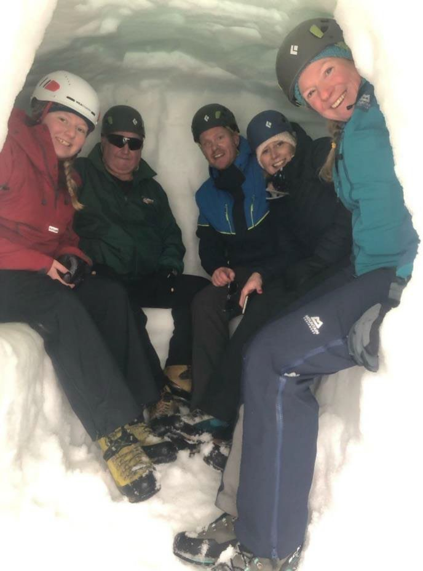

Caption: Image shows veterans hiking in the snow and using ice axes.
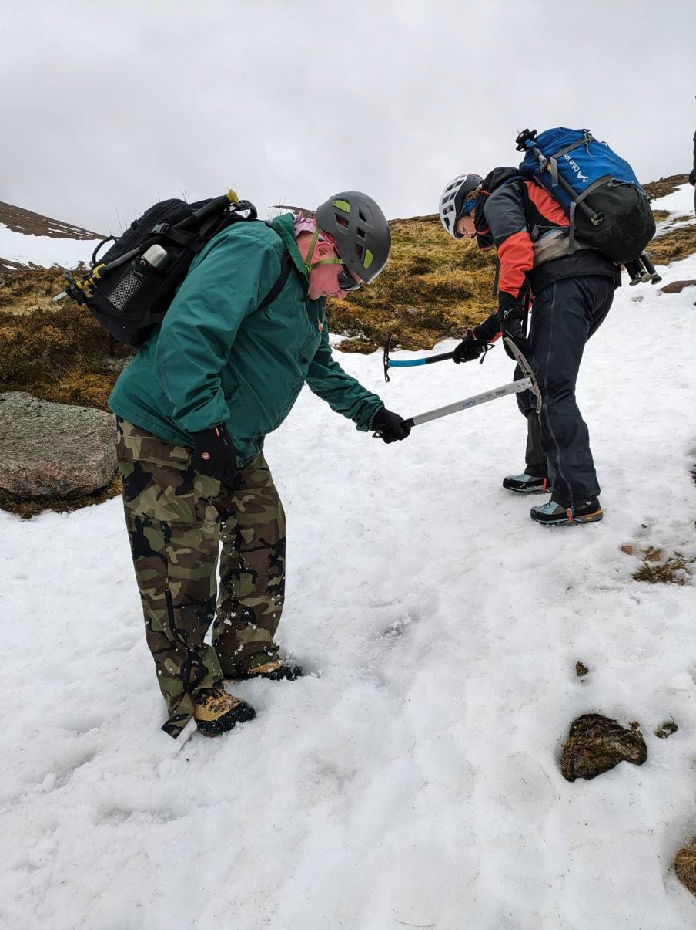
Image shows people climbing a snowy bank, at an incline, using ice axes.
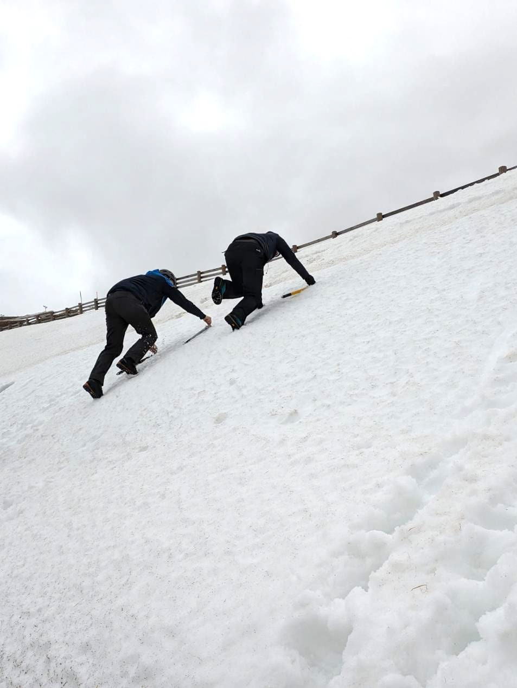

Veterans tee up at TopGolf
Sight Scotland Veterans recently organised a trip to TopGolf in Glasgow for 15 veterans to try out a high-tech golf experience.
Some veterans were trying golf for the first time, others were reconnecting with a passion they thought they could no longer do. Jim Tobin, an RAF veteran from Edinburgh, said: “I hadn’t played golf in 30 years because of my health and sight, but this gave me the opportunity to play again which was great and I thoroughly enjoyed it.”
David Macleod, who works as Sporting and Partnerships Worker at Sight Scotland Veterans, organised the event. He said: “While golf is traditionally a visual sport, it also relies heavily on tactile and auditory cues, so it is a good sport for blind and partially sighted people to take part in. TopGolf also takes out the walking aspect for our veterans, many of whom are older.
"It was great to see the joy on their faces. Some of our veterans had never played golf before and some had been forced to give it up due to their eye conditions; it was amazing to see them reconnect with a passion they thought they had lost."
Jason Duncan, Veterans Community Lead, said all kinds of sport are valuable for both mental and physical health. He encourages you to give us a call if you’d like to get involved in a sport.

If you are interested in playing golf, you can give our team a call on 0800 035 6409. We are putting on sporting events all over Scotland, including bowling, archery, golf, climbing, sailing, and even curling, and we’d love to hear from you and what you’re interested in.

Tips and Tricks:

An introduction to Smart Home technology
By Jason MacMillan, Assistive Technology Lead at Sight Scotland Veterans.

So, what is Smart Home technology?
Smart Home technology means your devices in your home all work together to make everyday tasks easier for you.
Some are controlled by apps and remote controls, but the ones that can make a real difference when you are living with sight loss are voice-controlled.
They can turn on and off lighting, heating, music, TV and much, much more. They can even control home security.
We are currently in a golden age with Smart Home technology. Once it was complicated, often expensive, and not altogether reliable. Now most things will work together (always check first though!) and are usually very easy to set up and install.
This is a very quick guide to the possibilities you might want to consider that could make some tasks streamlined and easier for you. All you need is broadband with Wi-Fi enabled (which is how the devices connect to each other).

Voice-Activated Assistants:
We have talked about devices like Alexa in previous articles, but there are several Voice Assistants out there. These devices listen to you and carry out your instructions.
With simple voice commands, you can control lights, adjust thermostats, set reminders, and even ask for the latest news, bus times or weather updates.
These devices provide hands-free control over various aspects of your home, eliminating the need for complex controls or physical interaction.

Smart Lighting and Heating Systems
Smart lighting systems offer the ability to adjust brightness levels and colour temperatures with just your voice.
Motion-activated lights can illuminate pathways, stairs, and rooms automatically, enhancing safety and reducing the risk of accidents.
Smart heating systems can be voice controlled and turned on and off, adjusted and even automated to alter the temperature and turn on and off at preset times making them very efficient and economical to your energy usage.

Voice-Controlled Appliances
Voice-controlled appliances, such as smart ovens, air-fryers, washing machines, kettles, and coffee makers, enable you to control them using simple voice commands. Whether it's preheating the oven and running it for a certain amount of time, starting a load of laundry, or boiling the kettle, these devices can enhance everyday tasks and routines.

Smart Home Security Systems
Smart home security systems provide peace of mind by offering real-time monitoring and alerts. From smart doorbells with built- in cameras to motion sensors and smart locks, these devices offer enhanced security features that can be managed remotely using a smartphone or voice commands.
You can receive notifications about potential intrusions, monitor activity around the home, and control access to your property.

Automation and routines
Nearly all smart home devices offer the ability to create routines and automation, where you can set things to turn on and off or adjust themselves automatically during the day or night.
In conclusion, Smart Home technology offers a lot of practical applications that can help empower you to live more independently and confidently.

Introducing JAWS, the most popular computer screen-reading software

By Amy M
Hello, I am Amy the Assistive Technology Intern here at Sight Scotland Veterans. I’ve got a visual impairment and I have used JAWS for over 10 years. JAWS is a piece of software that reads out what’s on a computer screen in a synthetic or robotic voice.
JAWS stands for Job Access with Speech, and like the name suggests, it is a screen reader used in offices and many homes around the world. I use it on a daily basis to enable me to do my job and also access a computer while at home. I use JAWS to browse the internet, send emails, create Word documents and much more. It’s just how I use computers – JAWS enables me to use a computer independently and access most of what my sighted peers are using.
The JAWS screen reader software is very customizable, meaning that users of any screen reader level can start to use it. It works with most modern applications such as Microsoft Office and browsing the internet. This means JAWS users can be productive while at home and at work.
JAWS users do not use the mouse to navigate the computer. Instead, we use many keyboard shortcuts to do what sighted users do with the mouse. JAWS also has its own keyboard shortcuts, and most users will, over time, have some committed to memory as they use them so often.

Here are some top tips for getting started with using JAWS.

Top tips
- JAWS can be set to tell you both the letters and words that you are typing. This is helpful if you are new to learning to type again.
- Jaws will tell you when you are in menus – for instance, in the text formatting ribbon.

Keyboard shortcuts
- Use Insert or Caps lock 1 to turn on JAWS help. This will tell you what key you are pressing and what the JAWS command is.
- Use Tab and Shift Tab to move around menus.

What’s next for JAWS?
- JAWS is improving all the time with each update. There is a lot of information and support out there to help with learning to use JAWS. You can find YouTube videos and podcasts explaining how to do useful things with JAWS in easy-to-follow steps.
- This is an overview of JAWS, but it should be noted that it is just one of several screen-reading software programmes available for Windows.

Get Involved

Join our 2024 trip to National Cenotaph in London for Remembrance Day.
Would you like to join our group heading to the National Cenotaph in London for Remembrance Day on 10 November 2024?
All veterans and their families, carers, and loved ones are invited to attend, even if you’ve participated before.
David Martin, who was a Lance Corporal in the Army, attended the Cenotaph parade in 2023.
David said: “This is such a life-changing experience. Think about it, would we ever have been able to go and show our respects to the fallen dead at the Cenotaph in London if we were not part of this fantastic charity? No. This is a life-changing experience for everyone who is taking part.”
John Reilly, Senior Centre Officer at the Hawkhead Centre, travelled with the 2023 contingent. John is a veteran himself, and he said: “I know when I march, I feel a range of emotions, but most of all, I just feel so, so proud. I am proud to be
marching with my comrades to pay my respects to the fallen, but also so honoured and proud to march alongside our veterans who are a true inspiration. I may be just 5’9” but in the Cenotaph I feel 6’6”, it is an amazing experience.”

The Cenotaph Parade will take place on Sunday 10 November 2024. If you’d like to find out more about attending in November 2024, please call our Sight Loss Support Line on 0800 035 6409.

Scottish Sight Loss Councils seeking participants who want to make a difference
Our new Sight Loss Councils are keen to involve people with vision impairment who have ideas about improving accessibility.
Led by blind and partially sighted people, Sight Loss Councils are groups where members can share and use their own lived experiences to tackle local and national issues. Through a Sight Loss Council, you could help improve the accessibility of services for people with vision loss.
The Sight Loss Councils are being run by Sight Scotland, Sight Scotland Veterans and Visibility Scotland, in partnership with the Thomas Pocklington Trust. With 23 Sight Loss Councils (SLCs) currently across England, our new Scottish Sight Loss Council is based on a tested model.
Each of our Scottish Sight Loss Council will be made up of a small group of volunteers with visual impairment. With a goal of bringing about real-word change, Sight Loss Council volunteers will meet monthly to discuss accessibility priorities and plan projects in their regions. These priorities could include transport and streets being accessible, so everyone can travel independently and safely. Sight Loss Council members could also work to increase the accessibility of healthcare, shopping, museums and sports facilities, depending on the local area. You can bring your ideas, and you can work with others on action plans to improve daily life for people impacted by visual impairment. And you can get ‘stuck in’ if you wish – these are “doing” groups. We’d love to hear from you if you’re interested.

Get involved
Are you interested in putting your name forward? You could call us, email us, or attend our launch events in April to learn more. You can call 0800 035 6409 to register your interest and Callum Lancashire, our Engagement Manager, will get in touch. You can also email callum.lancashire@sightscotland.org.uk.
If you live in the Central Belt, you are invited to attend our launch events for the Sight Loss Councils in April. Please RSVP by calling 0800 035 6409.

Sight Loss Council Launch Event – Edinburgh
- Date: Thursday 25 April 2024
- Time: 2 pm to 4 pm
- Venue: Summerhall – Library Gallery
- Address: 1 Summerhall Place, Newington, Edinburgh EH9 1PL

Sight Loss Council Launch Event – Glasgow
- Date: Tuesday 30 April 2024
- Time: 1 pm to 3 pm
- Venue: Visibility Scotland
- Address: 2 Queen's Crescent, Glasgow City Centre G4 9BW

Sight Scotland Veterans’ General Veterans Forum
Would you like to share feedback and ideas about Sight Scotland Veterans’ services? You can get in touch with your local representative through the General Veterans Forum.
Your representative on this forum is also a veteran with visual impairment who is receiving support from our organisation. You can call us on 0800 035 6409 to receive contact details for your local representative.
Through speaking with your local representative, other veterans and our teams, you can contribute your views around service development and delivery, in line with our organisation’s strategic aims and objectives. You can share suggestions for service development and you’ll receive feedback on the outcomes of any points raised. We greatly appreciate your assistance in continuing to improve our services.

General Veteran’s Forum representatives:
- Dundee – Alf Gibbons (Chair)
- Inverness – Rod Murchison
- Aberdeen – Harvey Grainger
- Stonehaven/Aberdeenshire – Ally Reid
- East Renfrewshire – Alan Reid
- Lothian – Seeking a new representative.
- Borders – Seeking a new representative.

Seeking representatives for the Lothian and Borders areas:
If you live in the Lothians or the Borders – and are interested in representing veterans - you can put your name forward for consideration. We are looking to recruit two veterans from these areas to the General Veteran Forum. You can contact us on 0800 035 6409 to discuss this further.

Sight Scotland Veterans’ Updates

Our Policy team’s recent campaigns
We are working to make Scotland a fairer society for people with sight loss by campaigning for positive change. Here are some recent highlights.

Political Party Conferences 2024
We headed into the Spring 2024 Political Party Conference season talking all things street accessibility. This year we brought an interactive board game that requires a player to make a journey from their house to the supermarket, encountering obstacles along the way – obstacles that people with visual impairment face daily. The board game demonstrates the importance of street accessibility for people with visual impairment and how issues such as street clutter, no colour contrast, and floating bus stops are barriers to the safety, independence, and confidence of blind and partially sighted people’s journeys.

Scottish Labour
We had a very successful weekend at the Labour Conference, where we were proud to win second best exhibition stall! It was great to speak to so many MSPs, MPs, Councillors, and delegates about street accessibility, tactile paving on train stations, and the campaign for a new eye hospital in Edinburgh.

Scottish Conservatives
In Aberdeen, we were pleased to meet with Miles Briggs, MSP and Sue Webber, MSP, whom we have been working closely with on our campaign for a new eye hospital (more information on the next page). We also raised the campaign with the Shadow Cabinet Secretary for Health and Social Care, Dr Sandesh Gulhane, MSP, and spoke with Graham Simpson, MSP, about the Fair Fares Review and what this means for free companion rail travel for blind and partially sighted people. We had great discussions about street accessibility, and lots of attendees played our board game.

Success in our Fair Fares Campaign
Great news! Transport Scotland has announced a pilot project to extend free rail travel for companions of Blind Persons Concessionary Travel cardholders.
This marks a big win for our Fair Rail campaign! After years of campaigning, we're one step closer to achieving equitable rail travel.

What is this campaign about?
Currently, there is no national policy for rail travel across Scotland that entitles free rail travel for the companions of blind and partially sighted people. With different concessionary and companion schemes in different areas, this causes confusion for both passengers and rail staff.

What our campaign calls for
- Free rail travel for the companions of those with a National (Scotland) Concessionary Travel for Blind Persons card.
- Accessible rail travel for blind and partially sighted people.
- A consistent policy across Scotland, wherever you are travelling.

Next steps: Pave The Way campaign
We are closer than ever to achieving equitable rail travel, and will seek to work closely with Transport Scotland and ScotRail to develop the pilot scheme. Our work for accessible train stations continues with the Pave The Way campaign.
Our “Pave the Way” campaign is calling for tactile paving on all train stations in Scotland. Without tactile paving to indicate where the platform ends, visually impaired people face a serious risk to their safety and could fall onto the train tracks.
In August 2023, the then Minister for Transport confirmed that phase 1 of the tactile paving at 18 stations was completed in March 2022. Network Rail has pledged to work with Scotrail to install tactile paving on all remaining rail platforms in Scotland by the end of 2023. This deadline has been and gone, and the remaining seven train stations in Scotland without tactile paving are no safer.
If you’d like to support this campaign, you can send a letter in support to the Cabinet Secretary for Transport. We have a template and suggested text on our website so it’s easy to send. This is available at: https://sightscotland.org.uk/pave-way
Thank you for your support.

George Street redevelopment
In March, we attended a site visit and meeting about plans for the redevelopment of George Street in Edinburgh, following news that it is being pedestrianised. We were eager to contribute to the proposed plans after an initial online meeting that was inaccessible for attendees with visual impairment.
It was great to attend both an in-person site visit and a meeting that involved the use of tactile models so that people with visual impairment could understand the designs and voice their concerns. We were, however, disappointed to learn that the proposed designs involved floating bus stops and uncontrolled crossings, all of which we voiced our concern about. Going forward, we plan to continue to feed into the plans at each stage of the development process.

Edinburgh Eye Hospital
Our campaign calling for quality eye healthcare for all continues.
183,000 people in Scotland are estimated to be living with sight loss. An estimated 45,260 of these individuals live in local authority areas served by the Princess Alexandra Eye Pavilion (PAEP). This means that 25 per cent of people in Scotland living with sight loss are served by an eye hospital that was declared unfit for purpose over 10 years ago. After the news that there is now a pause to all capital spend projects in NHS Lothian, we’re working with MSPs and the Scottish Government to ensure there are interim plans for existing and future patients to receive the quality eyecare they deserve.

Get in touch
If there are any policy-related issues you’re facing, please don’t hesitate to get in touch. You can call 0800 035 6409 and leave a message for us to contact you, or email policy@sightscotland.org.uk.

Footnote:
Thank you for reading the latest edition of Bugle. We promise to keep your information safe and will never sell or swap your details. We produce this newsletter in a printed format, in an audio format that is posted to you on a USB memory stick or a CD, and also in a digital format, emailed to you. If you would like to receive this newsletter in a different format, or you change your mind about receiving these newsletters, please email hello@sightscotlandveterans.org.uk
or call 0800 035 6409

