The Bugle, Winter 2024 edition
  - By Sight Scotland Veterans.

Table of Contents

Table of Contents 1
Upcoming events 3
February 3
Veteran Sight Support Groups 3
Dundee Visually Impaired Bowling Session 3
Archery sessions every Sunday at the Linburn centre 4
March 5
Veterans Sight Support Groups 5
Aberdeen Visually Impaired Bowling Session 5
Archery sessions every Sunday at the Linburn centre 6
A word from Gillian McDonald, Director of Operations 7
Veterans’ stories: Driving an ambulance across continental Europe 10
Veterans’ stories: Grants from Sight Scotland Veterans provide for a new bathroom in Fife 21
Types of grant we are offering: 23
Tips and Tricks: Meet Alexa and get started with Podcasts 24
So, what is a podcast? 24
Getting started 25
Tips and Tricks: Finding the right equipment for you 27
Get involved: Would you like to share feedback and ideas through our General Veterans Forum? 30
Seeking representatives for the Lothian and Borders areas: 31
Sight Scotland Veterans updates: Veterans travel to London for Cenotaph parade 32
Sight Scotland Veterans updates: An inspiring and emotional weekend I will never forget 39
Sight Scotland Veterans’ updates: Our Policy team’s recent campaigns 45
LNER Accessibility Forum 45
Eye Hospital Campaign 45
MSPs attend Remembrance Day 46
Carer’s Parliament 2023 46
Footnote 47

Upcoming events

February

Veteran Sight Support Groups
You can find out the venues for these Veterans Sight Support Groups by calling our Sight Loss Information Line on 0800 035 6409.
Dundee: Tues 13 February, 1:30 pm—3:30 pm
Seamill: Tues 20 February, 11 am–12:30 pm
Angus: Wed 28 February, call 0800 035 6409 for the start time.

Dundee Visually Impaired Bowling Session
Visually Impaired Bowlers Scotland (VIBS) is running a “Come and Try” session at Dundee Indoor Bowling Club on Saturday the 17th of February from 11 am to 1 pm.
Bowls is a fun, sociable, and friendly sport. Whether you are a complete beginner or have played before, you can try this activity in a relaxed environment, and you’ll receive assistance from experienced bowlers at this Come and Try session.
The next “Come and Try” session is at Aberdeen Indoor Bowling Club on Saturday the 9th of March from 2 pm to 3 pm. If you’d like to learn more, please contact Dominic Everett on 07463708068 or by emailing dominiceverett@gmail.com
Dundee Visually Impaired Bowling ‘Come and try’:
Date: Saturday 17 February 2024
Time: 11 am to 1 pm
Location: Dundee Bowling Club
Address: 15 Min Street, Dundee DD1 5BZ

Archery sessions every Sunday at the Linburn centre
Every Sunday, a coach from Scottish Archers is running free sessions for people with visual impairment at our Linburn activity centre in West Lothian. Archery can be great fun and you are welcome to join. Note, please arrange your own transport and bring lunch, as the centre is not fully open. If you have any questions, please call our Sight Loss Information Line on 0800 035 6409.
Key details:
Dates: Every Sunday: 11 February, 18 February,
28 February, 3 March, 10 March and so on.
Time: Drop in anytime between 10 am and 4 pm.
Location: Sight Scotland Veterans Linburn Centre, Louis Braille Avenue, Wilkieston EH27 8EJ

March

Veterans Sight Support Groups
You can find out the venues of these Veterans Sight Support Groups by calling the Sight Loss Information Line on 0800 035 6409.
Fife, Leuchars: Tues 5 March, 1:30 pm–3:30 pm
Dundee: Tues 12 March, 1:30 pm—3:30 pm
Hamilton: Thurs 14 March, 11 am—12:30 pm
Perth: Tues 19 March, 10 am—12:00 pm
Angus: Wed 27 March, call 0800 035 6409 for the start time.
Kilmarnock: Thurs 28 March, 1:30 pm—3:30 pm.

Aberdeen Visually Impaired Bowling Session
Visually Impaired Bowlers Scotland (VIBS) is running a “Come and Try” session at Aberdeen Indoor Bowling Club on Saturday the 9th of March from 2 pm to 4 pm.
Bowls is a fun, sociable, and friendly sport. Whether you are a complete beginner or have played before, you can try this activity in a relaxed environment, and you’ll receive assistance from experienced bowlers at this Come and Try session.
If you’d like to learn more, please contact Dominic Everett on 07463708068 or by emailing dominiceverett@gmail.com
Aberdeen Visually Impaired Bowling ‘Come and try’:
Date: Saturday 9 March 2024
Time: 2 pm until 4 pm
Location: Aberdeen Indoor Bowling Club
Address: Summerhill Rd, Aberdeen, AB15 6EE

Archery sessions every Sunday at the Linburn centre
Every Sunday, a coach from Scottish Archers is running free sessions for people with visual impairment at our Linburn activity centre in West Lothian. Archery can be great fun and you are welcome to join. Note, please arrange your own transport and bring lunch, as the centre is not fully open. If you have any questions, please call us on 0800 035 6409.
Key details:
Dates: Every Sunday: 3 March, 10 March, 17 March,
24 March, 31 March.
Time: Drop in anytime between 10 am and 4 pm.
Location: Sight Scotland Veterans Linburn Centre, Louis Braille Avenue, Wilkieston EH27 8EJ

A word from Gillian McDonald, Director of Operations
Welcome to our Winter edition of The Bugle. I hope you’re keeping toasty during this season.
It is easier than ever to get in touch — just call our Sight Loss Information team on 0800 035 6409. Our team can answer your queries when you call.
Through 0800 035 6409, you can also reach our services, including your local Independent Living Worker who will have visited you at your home. You can also reach our Rehabilitation team, our Financial Wellbeing teams, our Digital Hub, and our Sports and Partnerships team, which can help you get involved in sports and exercise. These teams are all here to help you live independently with a sight impairment.
We know there are other veterans experiencing visual impairment in every council area in Scotland who could benefit, like you have, from the support of Sight Scotland Veterans. We want to reach them too! We have developed services, such as the Sight Loss Information Line, so it’s easier to get in touch. Our Independent Living Workers have been linking in with partner organisations to spread the word and running Veterans Sight Support Groups across Scotland for everyone to join (find upcoming meetings on page 2). Now, we are reaching more veterans at an earlier stage in their sight loss journey.
You can help more veterans receive support too. If you know another veteran having trouble with their sight, please encourage them to call us on 0800 035 6409.
On page 10, we hear from an RAF veteran who answered a call for help. This veteran drove an ambulance 2,000 miles from Glasgow to a war zone in Bosnia as an act of charity. I hope you enjoy reading it.
With some facing financial difficulties this season, our Financial Wellbeing Service can offer support to those struggling. As we’ve shared previously, we are offering financial grants for veterans impacted by sight loss, just like you. On page 20, you can read about a veteran who received a grant for a new bathroom.
On page 23, our assistive technology expert Jason MacMillan writes about accessing podcasts on Alexa devices. I love listening to podcasts, with the incredible variety of shows you can access and new episodes coming out all the time. Have a read and see if it takes your fancy.
Also in this edition, we are seeking volunteers to join our General Veterans Forum, where you can meet other veterans and share your thoughts and ideas about services for people with sight loss. Read more on page 29.
For Remembrance Day in 2023, in addition to services at our activity centres, a contingent of veterans travelled to the National Service of Remembrance at Whitehall in London, supported by our staff. From page 31 onwards, you’ll find photos from the weekend and a first-person account from our Media and Stories Officer, Michael. Michael usually raises awareness of our charity in the newspapers and on TV news, helping more veterans find out about our services. Michael gives a report on some of the people he met, and the emotions he saw and felt, on this very special day.
Finally, we round off the magazine with an update from our Policy team on page 44, who are working to influence
decision-makers on matters that affect those with sight loss in Scotland. The team has big plans for 2024 which we’ll be in touch about.
Thank you, best wishes for the year,
Gillian McDonald
Director of Operations
Sight Scotland Veterans

Veterans’ stories: Driving an ambulance across continental Europe
In this article, we hear from a veteran from Wishaw, who drove 2,000 miles from Glasgow to deliver an ambulance to a war zone.
Gerald Waters is 91 now, but when he was a plucky 59-year-old, he drove across continental Europe. He drove to Bosnia early on in the Bosnian War in the Balkans, which took place from 1992 to 1995 following the break-up of Yugoslavia.
As Gerald tells in a book he wrote for his family: “In 1992, there was conflict in the Balkans. As in all wars, people suffer and there was a great need for food, clothing, etc. My wife Helene told me that two ambulances filled with medicine were being sent to Bosnia from the people of Glasgow, but unfortunately, they did not have a driver for one of them.”
Gerald had experience driving long distances, having run a family haulage business for 18 years.

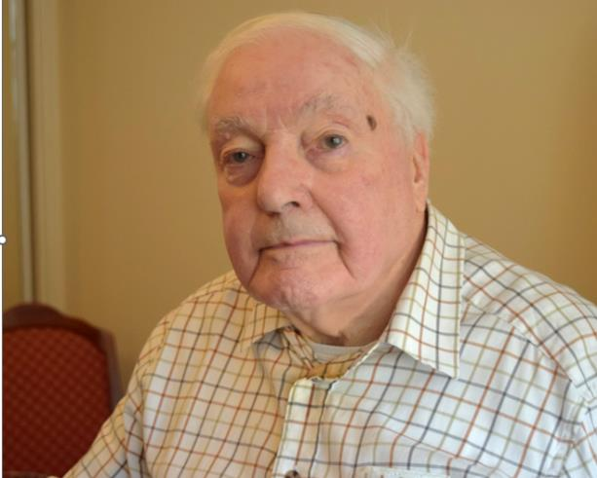
Gerald says: “I volunteered, and supervised the preparation of both vehicles at the ambulance depot. I made sure each had a spare wheel, jack and tools to effect running repairs on the 2000-mile journey to Bosnia. Our final destination was the town of Jajce in central Bosnia.”
The ambulances were loaded with medicines, wound dressings, surgical tubing, oxygen masks, syringes, and all manner of specialty paediatric, gynaecological and gastro-intestinal medicines.

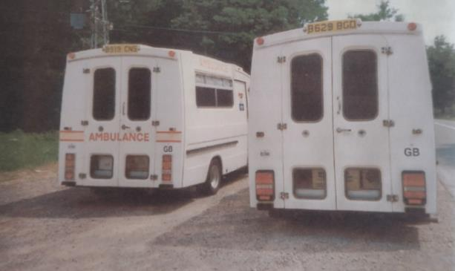
“Friar Ronnie Mitchell blessed both ambulances and we set off south in June 1992. We stopped in the Lake District, where we purchased about £50 of sweets. We crammed in tinned food and baby food, and put 4,000 toilet rolls on top.”
The convoy was joined by a Land Rover full of sterilizing equipment for operations, and a Croatian man named Mirco, who could speak Serbo-Croat.
Gerald says: “I had a co-driver, Dzon, who was on leave from the Croatian Army and wanting to get to Split. The other ambulance was driven by a Glaswegian businessman, Tony, and his sister Claire.

“Heavily laden, the three vehicles travelled to the port of Dover and boarded the ferry for the overnight channel crossing to Ostend in Belgium. We left Ostend and travelled across Belgium into Germany. The journey south through Germany was very interesting, passing well-known places such as Cologne and Heidelberg with frequent stops for fuel.
“We agreed not to look for overnight accommodation, but to drive non-stop, with one driver sleeping on top of the toilet rolls while the other drove.
“We crossed the Alps, which was a wonderful sight. I was driving on my own with Dzon asleep in the back. At 2 am, the moon shone on the glittering road and the town of Saltzburg was on the right, just barely discernible in the mist.”
The convoy travelled through Slovenia to Croatia, where they boarded a ferry to Split.
“The coastal road was being shelled and the main bridge that crossed a river had been destroyed. As we sailed south, there were explosions and flashes in the distance – not the best of welcomes,” Gerald said.
From Split, Gerald drove over the mountains into Bosnia and Herzegovina.
Gerald says: “Whenever we stopped for fuel, we gave out sweets to the children, and families would give us plum brandy. Just between you and me… it was terrible stuff.
“We reached the town of Tomislavgrad at about 8 pm to be told that the two ambulances had to be delivered further inland – it was too dangerous for us to go. I told them that we had brought these vehicles all the way from Scotland and that we knew more about the handling of them than young soldiers.”
A compromise was reached, and two guards armed with Kalashnikov automatic rifles joined the party. The final destination, the town of Jacje, was 10 hours drive away.
Caption: Image shows a Gerald and another man beside ambulance, holding an AK47 rifle.
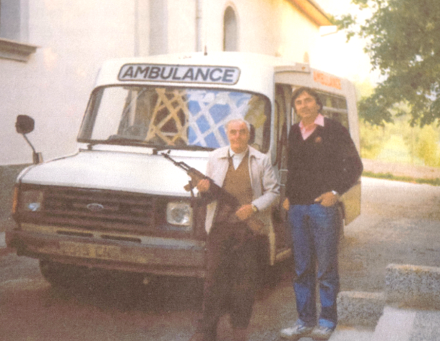
Gerald says: “The journey had to be undertaken in darkness, otherwise there was a danger of Serbian aircraft attacks. We left Tomislavgrad at 10 pm, turned off the main road, and drove into the forest. It was too dangerous to follow the main highway, which could be mined.
“We wore dark clothing as camouflage but could do nothing about the white ambulances. We drove on, and I had visions of Serbian tanks coming through the forest.
“At one point in the night, the armed guards went into a cottage to find out if we were on the right road. We were welcomed in for a meal of cold meat and tomatoes. Then we continued on.
“At 4:00 am, we came across a tanker loaded with petrol, blocking the road. Because there was a cliff face on one side and a river on the other, no one could get past. I thought, what on earth am I doing here, liable to get shot up and leave a widow and two sons without a father?
“One of the armed guards came into the ambulance and sat beside me. Sometime later I heard the sound of a truck approaching. It turned out to be an empty tanker that they had managed to bring up from the other side of the blockage, and they emptied one tanker into another.
“During this operation, the driver lit a cigarette, but the whole area was not engulfed in flames. To compound the carelessness, he bent over the tanker to check that all fuel was pumped out, with the cigarette in his mouth. I could not believe it was happening and that there had not been a gigantic explosion, with all the fuel-laden air.”
The empty tanker was pulled aside and the journey continued.
Gerald says: “With the possibility of machine gun fire being directed at us, I drove as fast as possible and entered the town of Jajce, our final destination. One ambulance immediately went to the local hospital and I hid my ambulance under trees so that it would not be seen from the air. After drinking a little plum brandy that was offered as a sign of welcome, we piled into a car and set off on the return journey.
“It was now 6:30 am. I learned later that the town of Jajce was besieged at the time, so how did we get into the town and deliver two ambulances loaded with medicine – a miracle?
“The Bosnians were amazed that Tony and I had driven the ambulances all that way from Glasgow to help them, so we received a great amount of appreciation. It took about two weeks and was quite an adventure. Once we got back to Split, we flew to Zagreb, then to London, and London back to Glasgow.”
Caption: Image shows a white church in Bosnia with pointed towers
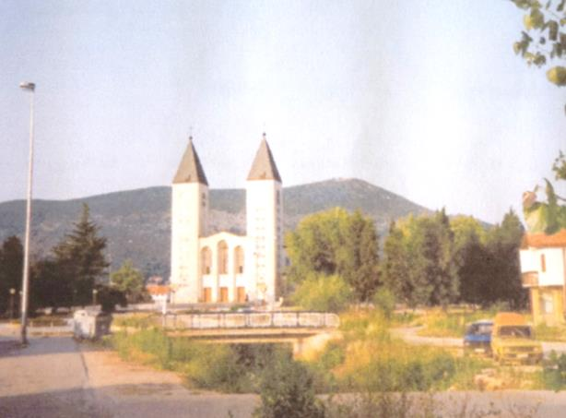

These days, Gerald is living in Wishaw. He has age-related macular degeneration and receives support from Sight Scotland Veterans. He uses a talking watch and a talking clock, and enjoys listening to audio books on a USB player that was supplied by Sight Scotland Veterans.
He says: “You just plug the USB memory stick into the player and push play. It’s very easy to use.”

Caption: Image shows USB memory stick, which can be plugged into a USB player to play talking books.
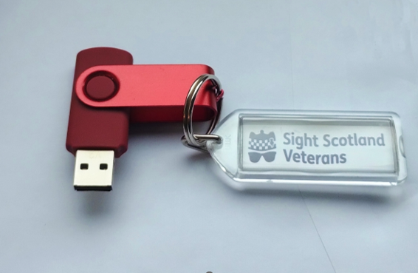
Caption: Image shows a USB player.
Gerald thinks back on his journey across Bosnia and is surprised by his boldness.
“On the way back, in Medjugorje, I was on the phone with my wife and offered the phone to Mirko, who drove the Land Rover. He said: ‘Hello Mrs. Waters… We were behind enemy lines last night’.
“He gabbled away for a minute or so, and then I did all I could to reassure my wife, 2,000 miles away in Glasgow, that it wouldn’t be long before I was home.
“When I think back on it, I did it out of charity, and I did it because I had experience with vehicles. I could speak a little German and a little French, but we managed it.”
If you’re interested in USB players or other ways of listening to talking books, please give our Sight Loss Support Line a call on 0800 035 6409.

Veterans’ stories: Grants from Sight Scotland Veterans provide for a new bathroom in Fife
Army veteran Jim Johnston has used one of our Sight Scotland Veterans grants to fund a new bathroom in his house in Kirkcaldy.
The grants exist to help people impacted by sight loss, like you. Each grant is considered on an individual basis, so the result of one application doesn’t impact any future decisions.
In the case of Jim, who served in the Argyll and Sutherland Highlanders and deployed in the Suez Crisis, Cyprus and Eden, the grant provided for a replacement bathroom, in a house he had recently moved into.
Jim, aged 86, said: “We had some savings and borrowed some money from our sons and bought the ground floor flat where we now live in Kirkcaldy. We knew some cosmetic work was needed in the flat, but unfortunately, after we moved in, we discovered that a lot more was needing done than what we first thought.
“We just had one problem after another. We called an emergency plumber to come out and reconnect the toilet and sinks so that we could use them, but the plumber advised us that the bath and sink were urgently needing replaced.
“We were then told the flooring under the bath was so rotten that if we use the bath there was a real chance the flooring could collapse. We didn’t know what to do, we couldn’t afford to replace it, we were in a desperate situation.”
Jim and his wife told one of our staff members about the bathroom during a visit to their home, and the couple were encouraged to contact our Financial Wellbeing Service at Sight Scotland Veterans and speak with Sue McKay, Financial Wellbeing Lead.
Jim said: “Sue McKay came out to see us and we talked through our situation, and she told us she would be delighted to support our application. Then a few weeks later we were told we had been successful.
“Sight Scotland Veterans organised everything for us. We got the whole bathroom ripped out, it was completely transformed with a new toilet, a new bath, a new sink, it has quite literally been life-changing. I can’t thank Sight Scotland Veterans enough.”
Sue McKay, Financial Wellbeing Lead at Sight Scotland Veterans, says: “Our Financial Wellbeing Service provides advice and information on financial matters including concessions, grants application, budgeting, and benefits.
“We want veterans to have the support and the financial confidence to continue living well in their own homes. I’d love to hear from any veterans who are looking for support.”
You can call us on 0800 035 6409 to arrange a call with our Financial Wellbeing Service, to talk about possible grants.

Types of grant we are offering:
1. Sight Loss Equipment Grant:
For white goods and brown goods, or digital equipment that helps you do the things you love.
2. Sight Loss Independence Grant:
For house repairs or adaptations.
3. Sight Loss Community Links:
Support to engage with local community activities, such as sporting equipment or membership joining fees.
4. Sight Loss Urgent Support Grant: Support to help veterans in urgent situations where no other option is available.

Tips and Tricks: Meet Alexa and get started with Podcasts
In the autumn edition of The Bugle, we discussed how smart speakers like Alexa devices offer amazing possibilities to help build independence and overcome barriers in everyday life, using just your voice. Alexa devices respond like a real person, answer questions, and perform the commands you give it.
Previously, we mentioned how you can ask Alexa to set a timer or an alarm, play music, or give you the weather forecast. You just say “Alexa,” then give your command.
This time, we are going to discuss a feature that people find
incredibly useful: Podcasts.
You don’t need to do anything complicated; Alexa devices play podcasts straight out the box.

So, what is a podcast?
A podcast is basically a series of on-demand radio episodes. The great thing about them is that you can find podcasts on any subject you can imagine, from history, to astronomy, to comedy and discussions on interesting topics.
Caption: Image shows an Amazon Alexa smart speaker.
There are two types of podcasts: audio and video. Today we are going to discuss audio. If you have an Alexa with a screen, you can ask for video podcasts, using the commands below.

Getting started
Let’s say your hobby is an interest in history.
Say: “Alexa, find me a podcast on history.”
It will now offer some options and if you want to play them, just follow the instructions, and play an episode.
You can try the same with any aspect of current events, comedy, drama, sports, politics, crime, technology news, literature, TV shows, films – any topic you can imagine.
Pro tip: Podcasts can use some colourful language, so if you don’t want that, you may want to say “Alexa, find me a clean comedy podcast”.
Podcasts are free and a fantastic way to keep up with news and information on your hobbies and interests.
Happy exploring!
- Jason MacMillan, Assistive Technology Lead

Tips and Tricks: Finding the right equipment for you
Our Rehabilitation team can help you find the best tools and equipment to adapt to life with sight loss. Here, we share how new equipment is helping a veteran who lives on the West Coast, which has some of the most beautiful landscapes imaginable. While many landscapes are quite accessible, some are a little out of the way.
Mervyn Storey is an Army veteran living near the West Coast in Lochcarron. This is the stunning Wester Ross area, 25 miles north of the Isle of Skye, with sea lochs and fresh ocean air. Mervyn has always been a very capable and independent man, and sight loss has had an impact on his life. One specific impact has been on his ability to read and do puzzles.
His Sight Scotland Veterans Rehabilitation Officer, Cheryll Hilton, visited and issued him with an excellent Explore 12 electronic magnifier to trial. While this proved fine for some basic reading, it was not proving easy for Meryn to do crosswords with the Explore 12 magnifier. A follow-up visit with a trainee in tow highlighted this issue and we looked for an alternative.
Introducing the Clearview with Speech! This electronic magnifier may be at the bulkier end of the scale, but its raised screen and easy-to-use scanning equipment plate made it ideal for this situation.
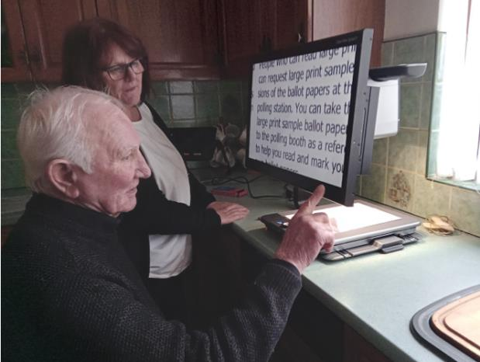
Mervyn was soon reading The Bugle, trying out crosswords and anything else to hand. He tried using the text-to-speech functions, and Mervyn was soon discussing the recipes he would be trying out.

Mervyn has been trialling the Clearview, and Cheryll will return and to ask if it’s working well for him. Rumour has it, she may be expecting to taste the results of some of those recipes Mervyn has been reading…
Our Rehabilitation team have the expertise and knowledge to assess and provide the most appropriate equipment to meet your needs. If you have equipment, such as a magnifier, which isn’t working so well, please get in touch with us on 0800 035 6409. Our Rehabilitation team is here to help.

Get involved: Would you like to share feedback and ideas through our General Veterans Forum?
You can get in touch with your local representative through the General Veterans Forum.
Through speaking with your local representative, other veterans and our teams, you can contribute your views around service development and delivery, in line with our organisation’s strategic aims and objectives. You can share suggestions for service development and you’ll receive feedback on the outcomes and actions being taken on any points raised.
Your representative on the forum is also a veteran with visual impairment who is receiving support from our organisation. You can call our freephone number to receive contact details for your local representative. We greatly appreciate your assistance in continuing to improve our services.

General Veteran’s Forum representatives:
Dundee – Alf Gibbons (Chair)
Inverness – Rod Murchison
Aberdeen – Harvey Grainger
Stonehaven/Aberdeenshire – Ally Reid
East Renfrewshire – Alan Reid

Seeking representatives for the Lothian and Borders areas:
If you live in the Lothians or the Borders – and are interested in representing veterans - you can put your name forward for consideration. We are looking to recruit two veterans from these areas to the General Veteran Forum. You can contact us on 0800 035 6409 to discuss this further.

Sight Scotland Veterans updates: Veterans travel to London for Cenotaph parade
Remembrance Day is a poignant day, every year. It is a time to remember those servicemen and servicewomen, and lost family, friends and squad mates, who gave up so much so we can live the lives we do today.
In 2023, in addition to services at our activity centres, we organised a coach trip to London for veterans with sight loss to march in the Cenotaph Parade on Remembrance Day. Here are photos from the trip, which included a visit to RAF Hendon Museum. We also have a first-person account of the day from Michael Donaldson, our Media and Stories Officer, who travelled with our staff and the veterans to cover the event. We hope you enjoy.
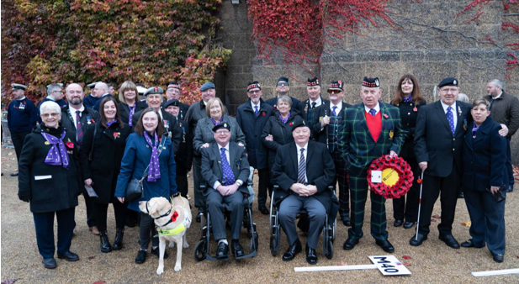
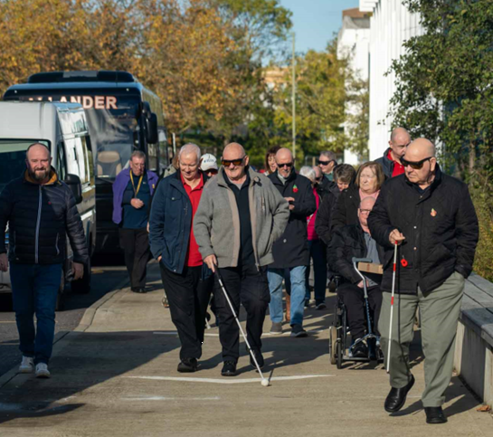
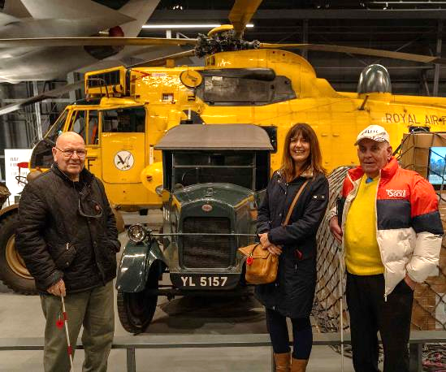
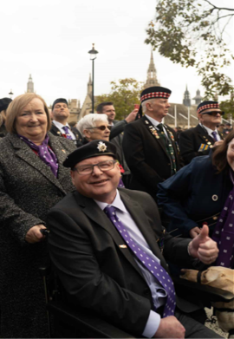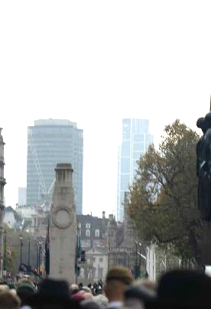
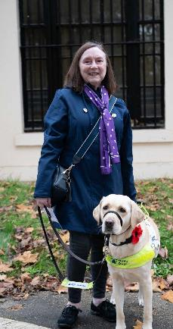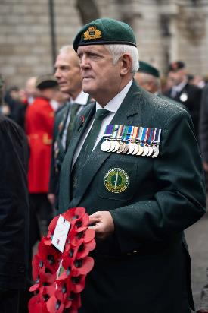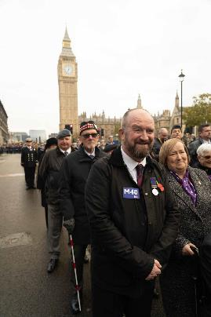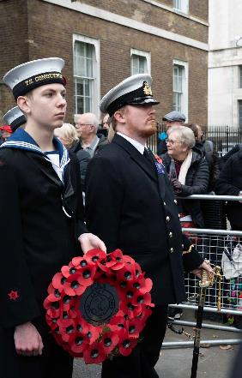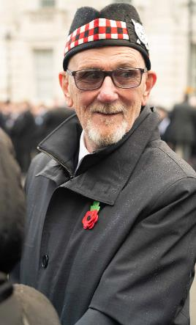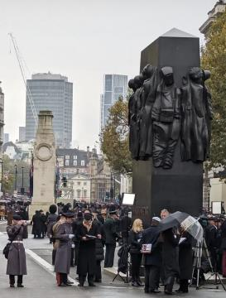

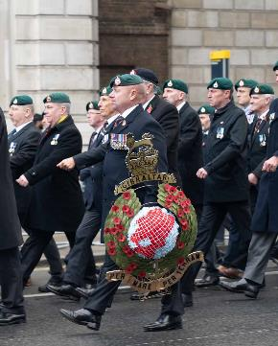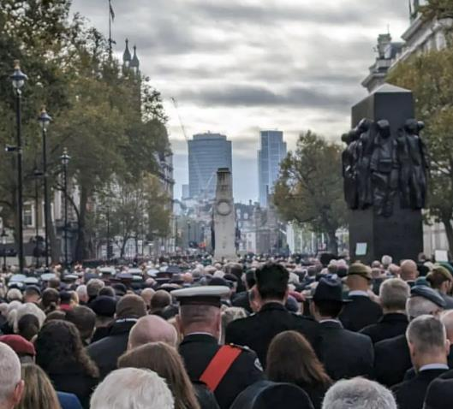

Sight Scotland Veterans updates: An inspiring and emotional weekend I will never forget
By Michael Donaldson, Media and Stories Officer for Sight Scotland Veterans.
Remembrance Day has always been important to me, but if I’m honest, I didn’t really understand what it truly represents. It is safe to say that this has all changed now.
For a non-veteran, to march in the Cenotaph Parade in London was something I should never have been able to do, but it was one of the most emotional and inspirational experiences of my life. I was asked to create content for the Cenotaph trip so others could see what it means to our veterans, unaware of the profound impact it would have on me personally. To be able to offer help and support to a group of blind veterans on one of the most important trips of their lives was both inspiring and humbling.
The emotions leading up to the weekend were mixed, as on the one hand, I was so proud to help and support our Sight Scotland Veterans and to be able to mark the occasion by sharing their feelings and experiences.

Caption: Veteran David Martin (left) with Michael Donaldson, Media and Stories Officer for Sight Scotland Veterans.
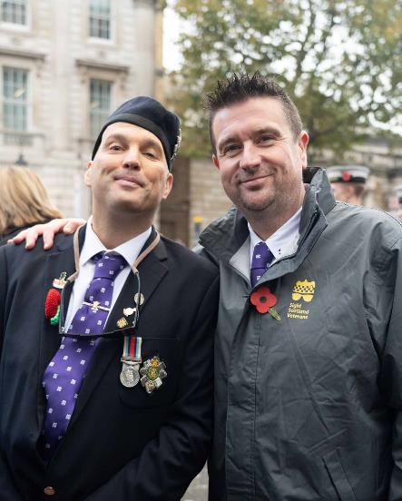
But on the other hand, I felt like a phony, thinking I had no right to be marching alongside all these inspirational people who quite literally put their lives on the line to protect our freedoms.
As soon as we met up with the veterans in London you could sense the excitement, the camaraderie and respect. The veterans may have just spent over 10 hours on a bus, but there was no complaining (apart from the staff), as they gathered in the hotel bar to share stories and laughter well into the night. Some of the veterans knew each other, some had never met before, but it was a joy to behold seeing them all coming together like old friends. My photographer sidekick Mauro and I were immediately welcomed into the group and it wasn’t long before the shouts of ‘not another bloody photo’ or ‘how many videos do you need’ were heard ringing around the hotel.
Remembrance Sunday was an early rise, with Mauro and I being the last to get on the bus. We were met with a loud cheer and a round of applause. All the veterans were dressed immaculately, each proudly representing their different regiments. There was a different feeling on the bus as we drove through London that morning, and you could tell that emotions were already running high as our veterans prepared to honour the fallen and march with fellow comrades.
As we gathered in Horse Guards Parade, the air was full of nervous tension and anticipation. It almost felt uncomfortable and rude to ask our veterans for photographs and interviews to mark the occasion, but I need not have worried. Every one of them was delighted to help and tell us about how proud and emotional they were to be at the Cenotaph, and how special it was to march alongside the friends they have made at Sight Scotland Veterans.
David Martin, who was a Lance Corporal in the Army, summed it up by saying: “This is such a life-changing experience. Think about it, would we ever have been able to go and show our respects to the fallen dead at the Cenotaph in London if we were not part of this fantastic charity, no. This is a life-changing experience for everyone who is taking part.”
We then began moving from Horse Guards Parade to Whitehall where we were put in position to take part in the march. Despite the long wait and rain, our veterans remained in high spirits as they took in the atmosphere. It was here where one of our veterans, Tommy, somehow met up with two old army friends he hadn’t seen in years and wiping away the tears of happiness he declared ‘what are the chances of seeing them out of 10,000 people, it’s just unbelievable’. John Reilly, our Senior Centre Officer at the Hawkhead Centre, who is also a veteran, then spotted and an old army friend who he had seen once in forty years, again full of emotion and amazement he relayed ‘what are the chances, what are the chances.’
When the march began the atmosphere was charged with dignity and pride as each step taken marked a tribute to the sacrifices made. The fact I was walking alongside blind and partially sighted veterans, who had been through so much in both their professional and personal lives, made the experience just so much more powerful with every step representing a message of resilience, courage, and commitment. They did not feel sorry for themselves, they did not see vision loss as a barrier, they were marching with fellow comrades to honour those who made the ultimate sacrifice, and the pride was bursting out of them.
I went to London to create content so others could see the importance of Remembrance Day and what marching in the Cenotaph meant to our veterans. Little did I realise the personal impact it would have on myself, serving as an education about the significance of Remembrance Day through conversations, shared laughter, tears, and the formation of new friendships. I feel honoured to have shared this experience with our inspirational veterans, and the Sight Scotland Veterans staff.

So Remembrance Day is about respect, and honouring our veterans who are gone and still here, but it is also about education. As many of my veteran friends told me throughout the weekend, ‘we need to get the message across to the youngsters, we need to get them to remember what has happened in the past, what people had to give up, so they don’t repeat our mistakes’.
#LestWeForget

Sight Scotland Veterans’ updates: Our Policy team’s recent campaigns
We are working to make Scotland a fairer society for people with sight loss by campaigning for positive change. Here are some recent highlights.

LNER Accessibility Forum
People with visual impairment have raised with us that many train stations are difficult to navigate, with some not having tactile markers on the ground to indicate dangerous areas, such as the edge of platforms. In November, we attended LNER’s Accessibility Forum in Edinburgh and discussed with LNER how to improve tactile paving and tactile wayfinding, and processes for passenger assistance. The LNER customer service team also told us about new Passenger Assist Lounges, which will be introduced in Edinburgh Waverley and Newcastle stations. LNER mentioned they are in the process of purchasing new trains. At the next Forum meeting in January, we hope to explore these trains using tactile models.

Eye Hospital Campaign
We are campaigning for a new eye hospital for Edinburgh. The Edinburgh Eye Pavilion was declared unfit for purpose in 2014. Despite the Scottish Government promising a new eye hospital in 2018, five years later, we have been told that the opening has now been delayed further.
We are calling for the Scottish Government to commit funds to a new eye hospital. You can sign our petition online and make your voice heard at sightscotland.org.uk/new-eye-hospital.
If you’d like our Sight Loss Information Line staff to sign the petition on your behalf, please call us on 0800 035 6409.

MSPs attend Remembrance Day
Paul Sweeney MSP and Neil Bibby MSP paid their respects at our Remembrance Day services at Hawkhead this year.
The politicians met with a number of veterans with sight loss, laid a wreath, and commemorated the afternoon with us.

Carer’s Parliament 2023
Our Policy team attended the Carer’s Parliament to hear from unpaid carers across Scotland about the key issues that they are facing.
We also heard from the Minister for Social Care, Mental Wellbeing and Sport, Maree Todd MSP, about what the Scottish Government is doing to improve both the lives of carers, and the care that is available. In the afternoon, we contributed to discussions about the new National Transitions to Adulthood Strategy for Disabled Young People and Self-Directed Support. We hope to continue to work with the Scottish Government on this strategy as it develops into consultation in the new year.

Footnote
Thank you for reading the latest edition of The Bugle. We promise to keep your information safe and will never sell or swap your details. We produce this newsletter in print, audio and digital formats. If you would like to receive this newsletter in a different format, or your change your mind about receiving these newsletters, please email hello@sightscotlandveterans.org.uk or call 0800 035 6409.
End of text.

