The Bugle - Autumn 2023 edition
Sight Scotland Veteran’s newsletter

Contents Page number
Events and activities you might be interested in 4
A message from Gillian McDonald, Director of Operations 8
Veterans’ Stories
Marathon-running veteran recommends tandem cycling 11
WWII veteran recalls missiles across English skies 15
Nurse conquers the West Highland Way with aid of binoculars… 23
Creative Corner
Poems by REME Veteran Colin Weir 26
Tips and Tricks
Meet Alexa: Getting to know your Voice Assistant 29
Get Involved
A survey about technology and sight loss 33
Take part in a podcast about your transition to Civvy St 35
Sight Scotland Veterans Updates
New opportunities to get involved in sports 36
You can receive our easy-listening audio magazine 39
You could be eligible for our 2024 Winter Grant 40
Our Policy team’s recent campaigns 42

Events and activities you might be interested in

November

Remembrance services at Sight Scotland
Veteran’s Hawkhead and Linburn activity hubs
Date: Friday 10th November, 10:30 am—1 pm
You and a guest are invited to join us for Remembrance services at either our Hawkhead Activity Hub or our Linburn Activity Hub on Friday 10th November. Times are 10:30 am arrival for a 10:55 am start. You are welcome to stay on and join us for lunch. The day is expected to finish at 1 pm.
Please RSVP and advise us of any dietary requirements for
you or your guest.

Locations: Hawkhead Centre, 198 Hawkhead Rd, Paisley PA2 7BS
Linburn Centre; Linburn Centre, Louis Braille Avenue, Wilkieston EH27 8EJ

Please RSVP to:
Hawkhead attendance: telephone 0141 370 8050 or email john.reilly@sightscotlandveterans.org.uk
or alison.gray@sightscotlandveterans.org.uk
Linburn attendance: telephone 0131 333 1369 or email mary.johnston@sightscotlandveterans.org.uk
or Jacqui.salter@sightscotlandveterans.org.uk

November

Archery session at Hawkhead Centre
Date: Saturday 18 November, from 10 am to 12 noon.
Also held on Saturday 9 December, from 10 am to 12 noon. Location: Sight Scotland Veteran’s Hawkhead Centre,
198 Hawkhead Rd, Paisley PA2 7BS
You’re invited to spend some time with a bow at this session being run by Scottish Archery. You can learn tips on proper posture, breathing techniques, and bow handling, ensuring that
you become more proficient with each arrow you loose. Whether you are a seasoned archer or a complete novice, archery sessions can be thrilling experiences that connect you with your primal instincts and sharpen your focus and discipline. Please note,
lunch and transport are not being provided, so please make your own arrangements. You can RSVP to our Sight Loss Information Line if you’d like to attend: 0800 035 6409.
5

November

Veterans’ Sight Support Groups
You can meet with other veterans with sight loss at our Veteran Sight Support groups. Please call us on 0800 035 6409 for details the meeting venue.
- Dunblane: Wed 1 November, 12:00–1:30 pm
- Fife: Tues 7 November, 1:30 pm–3:30 pm
- Kirkcaldy: Wed 8 November, 11 am–12:30 pm
- Hamilton: Thurs 9 November, 11 am–12:30 pm
- Perth: Thurs 16 November, 10 am–12 noon
- Inverness: Mon 20 November, 11 pm—2:00 pm
- Dundee: Tues 21 November, call us for the time.
- Inverurie: Wed 22 November, 11 pm—1:00 pm
- Angus-Carnoustie: Wed 22 November, 1.30 pm—3.30 pm
- Moray: Mon 27 November, 10 am–1:00 pm
- Seamill: Tues 28 November, 11:30 am–1:30 pm
- Aberdeen: Wed 29 November, 11:30 am–1:30 pm
- Dumfries: Wed 29 November, 11 am–1:00 pm
- Kilmarnock: Thurs 30 November, 1:30 pm—3:00 pm

6

December

Archery session at Hawkhead Centre
Date: Saturday 9 December, starts at 10am—12 noon. Location: Sight Scotland Veteran’s Hawkhead Centre, 198 Hawkhead Rd, Paisley PA2 7BS
You’re invited to spend some time with a bow at this session being run by Scottish Archery. You can learn tips on proper posture, breathing techniques, and bow handling, so you
become more proficient with each arrow you loose. Please note, lunch and transport are not being provided, so please
make your own arrangements. Please RSVP to our Sight Loss Information Line on 0800 035 6409.

Veterans’ Sight Support Groups
You can meet with other veterans with sight loss at these groups. Please call 0800 035 6409 for the venue.
Fife: Tues 5 December, 1:30 pm–3:30 pm
Angus-Carnoustie: Wed 13 December, 1:30 pm—3:30 pm Hamilton: Thurs 14 December, 11 am–12:30 pm
Perth: Thurs 14 December, 11 am–1:00 pm Inverness: Mon 18 December, 11 am–2:00 pm Moray: Wed 20 December, 10 am–1 pm
Kirkcaldy: Wed 20 December, 11 am–12:30 pm

2024 Events:
We’ll resume our Veterans Sight Support Groups in March when it’s easier and safer to travel to groups. Dates for events in March will be shared in the Winter 2023 edition of The Bugle.
7
Have a cozy winter until then!

A message from Gillian McDonald, Director of Operations

Welcome to our autumn edition of The Bugle. At Sight Scotland Veterans, we are passionate about helping you to manage and mitigate the challenges of sight loss – and to live well.

As the weather grows colder, you may be thinking about heating bills. We might be able to help with these, if you’re
spending more than a quarter of your income on heating bills or receiving means-tested benefits. You can read about our Winter Grant on page 40, towards the back of the magazine.

The turn of the season can also make it harder to exercise and keep active. But, for all of us, exercise is so important to our mental and physical health. I’d love to introduce you to Judith Crawford and David McLeod, our new Sports and Partnerships Workers. Judith and David are connecting with sports clubs across the country and working on ways to help you and other veterans with sight loss to access sports and exercise in your
community. Page 36 has more information.

On the topic of exercise, we also have stories from some very dynamic veterans. On page 11, hear about an ex-army
mechanic who is loving tandem cycling. On page 15, you’ll witness the indomitable spirit of a former army nurse, who
walked the West Highland Way and used binoculars to mitigate the challenges of her sight loss.

These stories might spark some ideas about exercises you could try but if these aren’t for you, then there are lots of other sports that could be of interest.

Our feature story comes from World War Two veteran, Jean Smart, who vividly recalls tracking Doodlebug missiles across
English skies. It’s a wonderful read, which you’ll find from page 15 onwards.

In our "Creative Corner", we have poems by REME Veteran Colin Weir, delving into the depths of emotions on page 26.

The "Tips and Tricks" section on page 29 overviews the
advantages of Alexa, a digital voice assistant device, and details some of the areas it can support everyday tasks. We would also love to hear your experiences with digital technologies
– particularly if you’re not so confident with digital technology, or have become less confident since experiencing sight loss. On page 33, we have info on how to share your experience.

If you’re interested in receiving audio content to listen to, turn to page 39 to learn about our Wellbeing Audio Magazine, and how to join the mailing list.

Lastly, on page 42, read about our Policy team’s work trying to reduce barriers to safe travel, including difficult intersections, and the importance of having bumpy paving on the edge of
train station platforms.

My final thought is to the memories of our servicepeople and their sacrifice, which are being commemorated on
Remembrance Day. This year, on Friday 10th of November, we are holding Remembrance services at our Hawkhead and
Linburn activity hubs in Paisley and West Lothian. You and a guest are invited to join us for these Friday 10th November
commemorations, and for lunch afterwards, so please RSVP if you are interested. Details are on page 4. If you’d like to watch Linburn’s service over the internet on Zoom, please contact our Sight Loss Information Line on 0800 035 6409.

Elsewhere in the country, our Independent Living team will be attending memorials in their local areas, and a group of
veterans are also representing Sight Scotland Veterans at the
National Service of Remembrance at Whitehall in London. As we pay our respects on this solemn day, know that our appreciation for you and your fellow veterans extends far beyond these
commemorations. It is our daily commitment to ensure that you receive the support you need and that your service is never
forgotten.

Please get in touch with us by calling 0800 035 6409 if you would like to discuss anything further.

Thanks for reading, take care,

Gillian McDonald
Director of Operations Sight Scotland Veterans

Veterans’ Stories

Marathon-running veteran recommends tandem cycling

A Perth veteran who used to run marathons is now enjoying
tandem cycling to get his heart rate going.
John Reid, who served in the Royal Electrical and Mechanical Engineers from 1973 to 1992, highly encourages other people impacted by sight loss to take a tandem bike for a spin with a carer or loved one.
“I’ve been doing laps of the North Inch in Perth with a hired tandem bike,” John said.
“It’s a tricycle, with two seats side-by-side. My sister sits next to me and does the steering, and we’ve done 18 laps of the Inch. It has worked out to about 27 miles in total now.”
John, in his late 60s, said he’d get into a great rhythm during the laps.
“The actual cycling is okay, but when I get off the bike my legs feel like jelly. It takes half an hour before I can walk properly.
It’s good for you and gets you out and about… until it rains. We got soaked one of the times. When you’re halfway around it and it starts raining, you have to get to cover quick!”

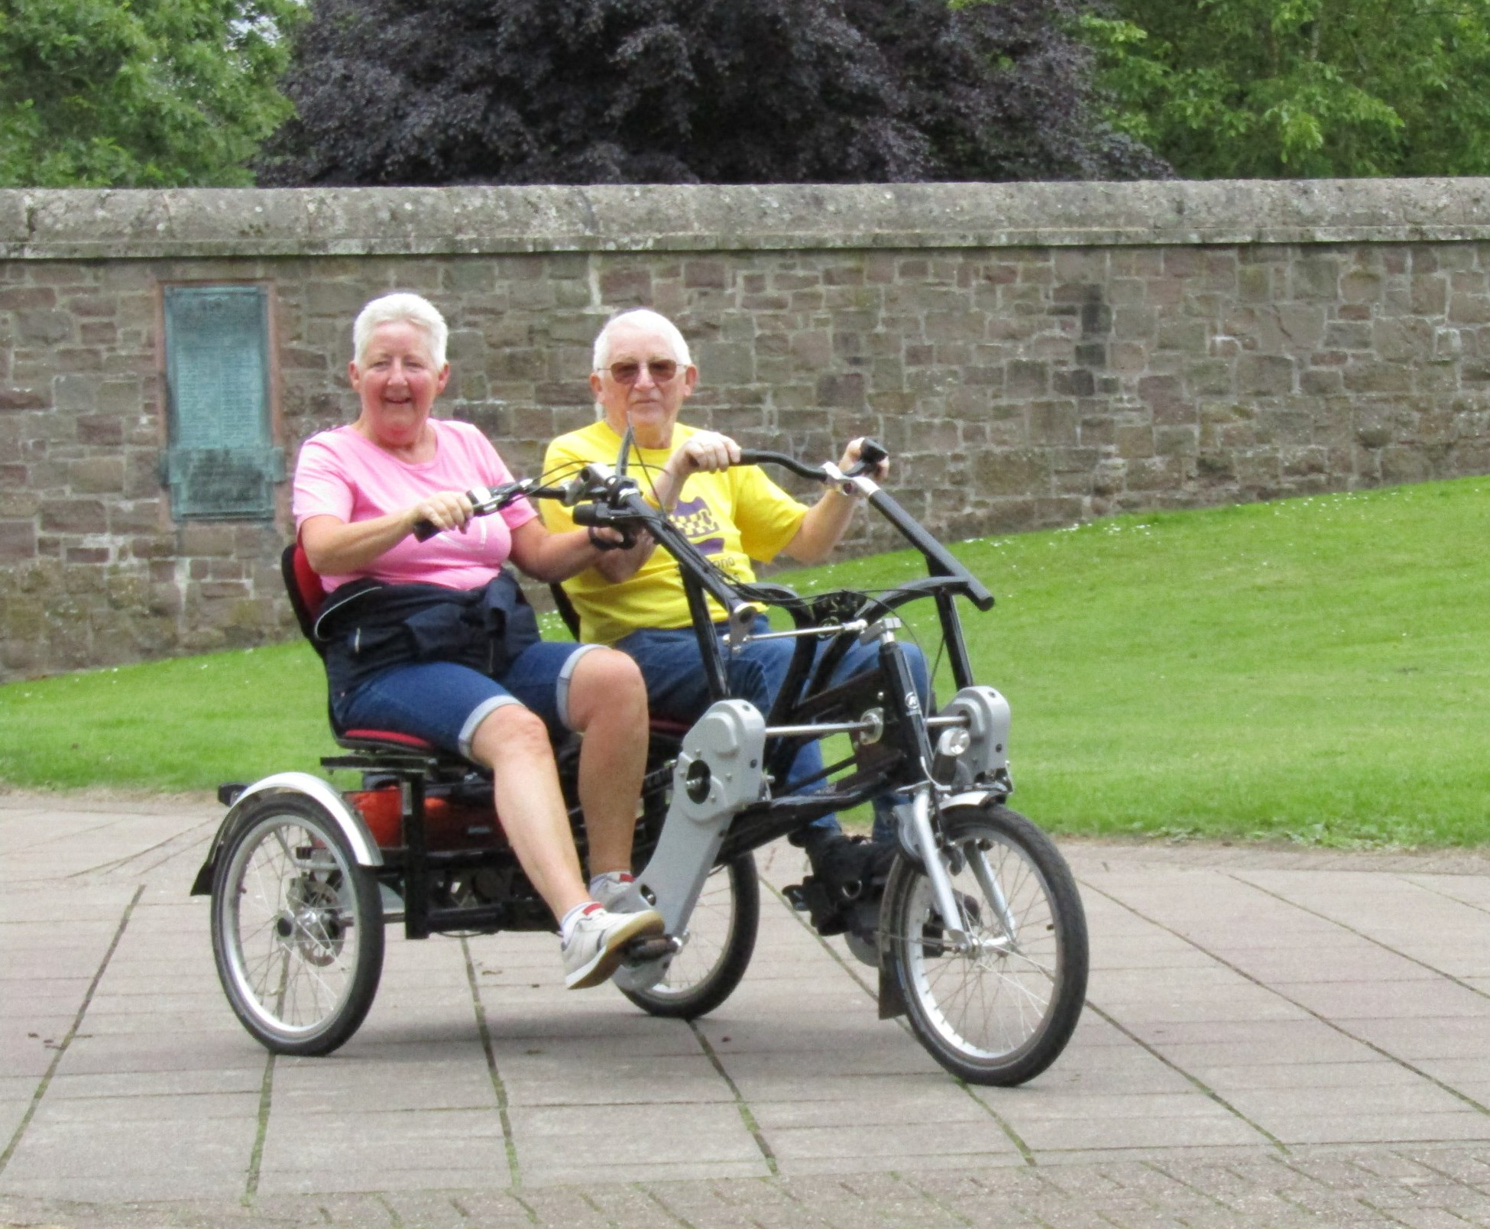

John served in Germany for nine years, two years in Gibraltar, and three years in Northern Ireland. His last two years were at Fort George in Inverness.
“I was a motor mechanic and mainly worked on Landrovers and small trucks – though I did also work on a Scammel commander tank transporter. That had a Rolls-Royce engine that was bigger than a family car,” he said.
A keen long-distance runner, John used to take time off to run marathons in Germany.
“Between the ages of 26 and 39 years, I did 17 marathons.”

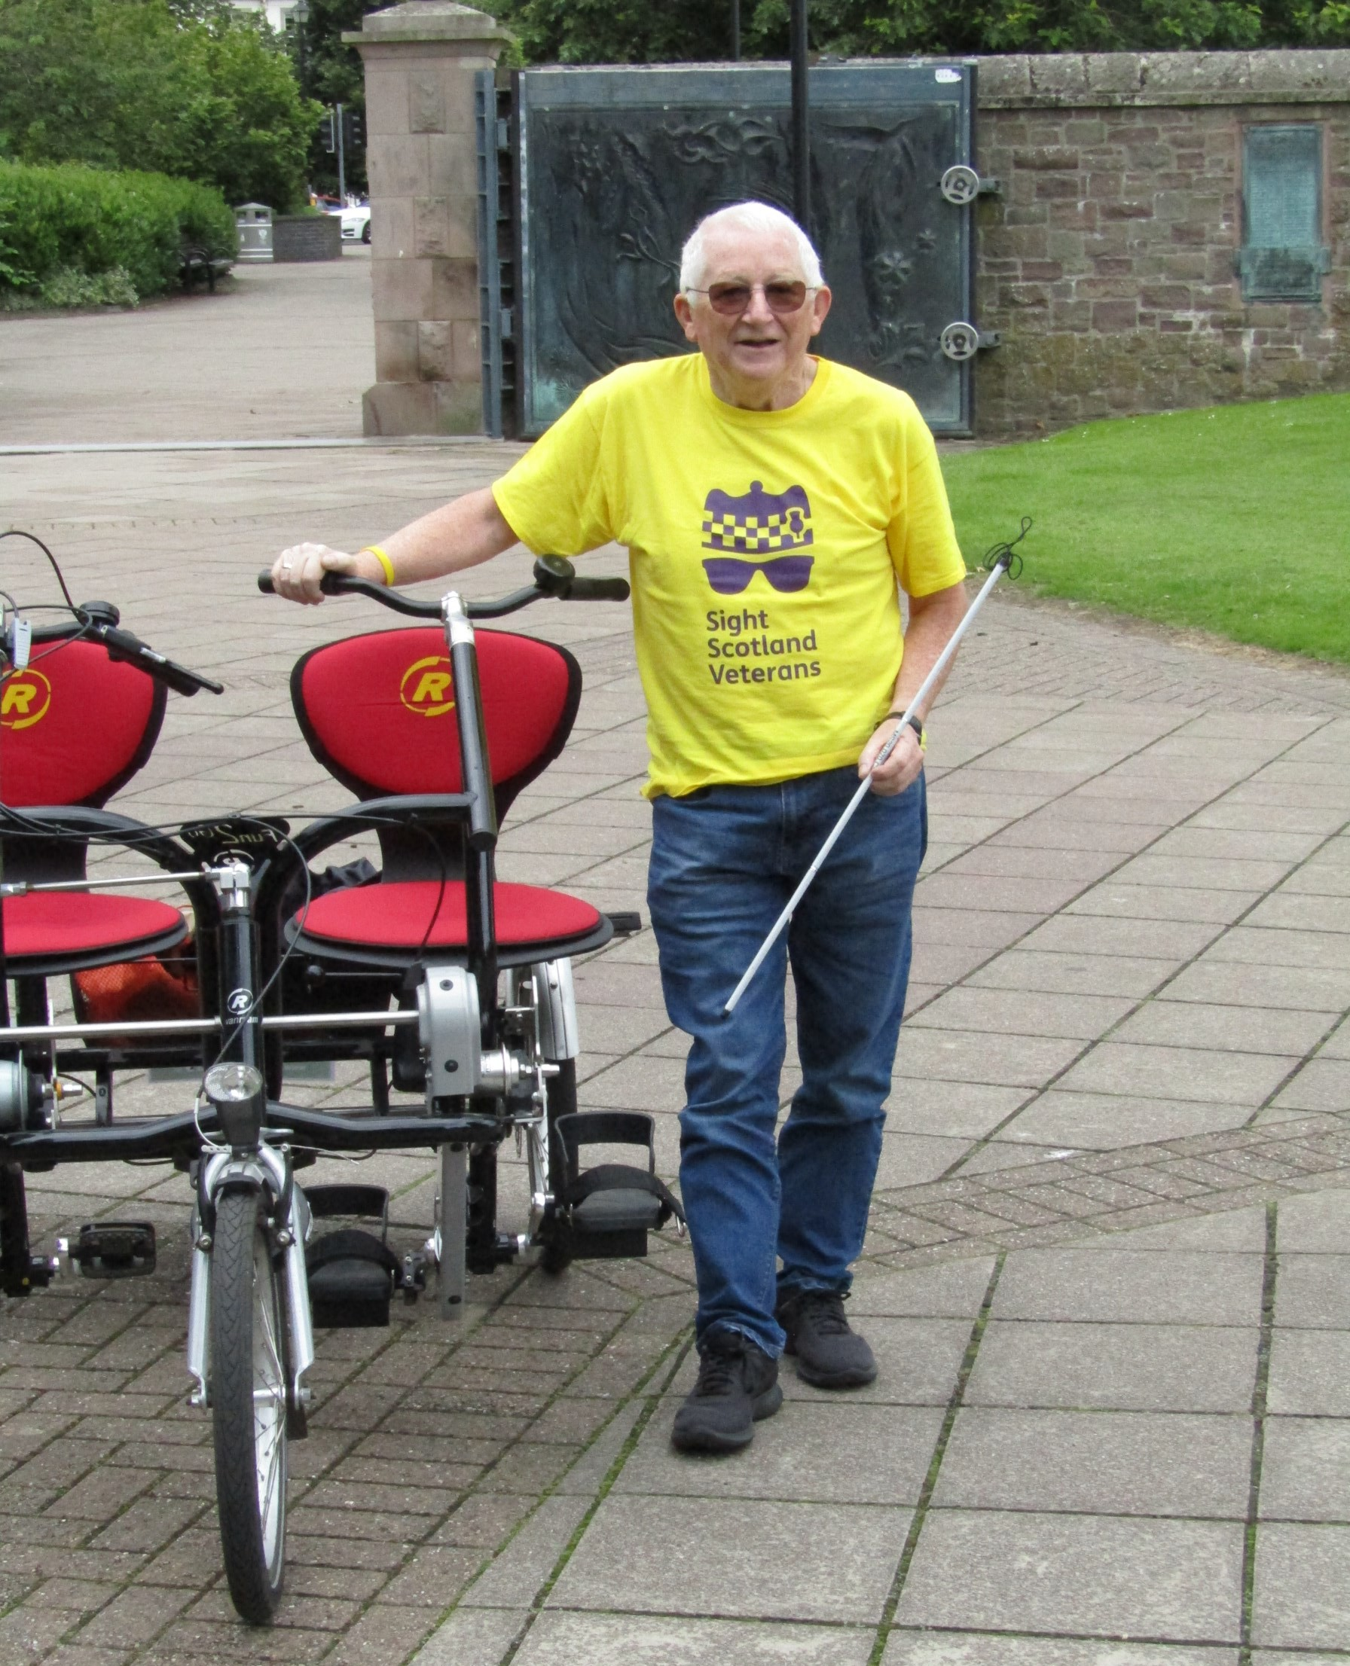

John ran the Berlin marathon just before the Berlin Wall came down.
“I ran around it. While it was up, we went across the border into East Berlin and thought we would buy Christmas presents
because it was very cheap. But all the toys were like those that Britain had 30-40 years earlier. It was so behind the times.”

“We went into a restaurant for a complete meal and it was so cheap that we ended up giving the waiter a bigger tip than the price of the meal.”
While serving in Northern Ireland, John experienced an injury that changed his life.
“I fractured part of my skull playing football. We were playing indoors on a concrete pitch and that’s what’s caused me to lose part of my sight and caused epilepsy and memory loss.
“I felt okay for many years, but when I got out of the Army, I started having problems. The doctors said, because I was so fit in the army, it was keeping all the problems at bay. When I came out, I started getting epilepsy. It’s okay once you get it
under control; it’s controlled by tablets now.”
These days, in addition to cycling, John enjoys visiting Sight
Scotland Veteran’s Linburn Centre on Wednesdays.
“Woodwork is my favourite activity at Linburn. Making things like planters, wheelbarrows and bird tables.”
Through his tandem cycling, John has collected more than £180 in donations for Sight Scotland Veterans.
“The charity has done so much for us. It’s about putting a little bit back to Sight Scotland Veterans,” he said.
For anyone interested, the company hiring out the tandem bikes in Perth is called Bells Sports Centre.
You can call them for information about hiring a tandem bike in Perth on 01738 454647. You can also turn to
page 36 to learn about our staff focused on connecting you with sports and activities.

Veterans’ Stories

WWII veteran recalls tracking Doodlebug missiles across English skies

World War II veteran Jean Smart has always appreciated smart equipment – whether it’s a spill-preventing one-cup kettle she uses these days, or a magnetic stick she used to help chart the path of flying bombs.
Jean served in the RAF from 1942 to 1946. Volunteering at the age of 18, she had originally enquired about the Women’s
WRENS, but, as she jokes, she changed to the RAF because “I didn’t like the WRENS hat”. Incidentally, the hat’s design changed later.
In July 1942, she trained as a plotter at RAF Woodvale near Liverpool and learned to listen to the Royal Observer Corps’ reports from sites throughout the country.
Jean’s plotting skills were soon required in the south of England.
As Jean describes: “There wasn’t much activity at first, but then in 1943, Hitler brought out his special weapon, the Doodlebug
flying bomb. I was sent to the Biggin Hill Ops Room in Kent,
along with several others from Woodvale. My job title was Clerk, Special Duties.”

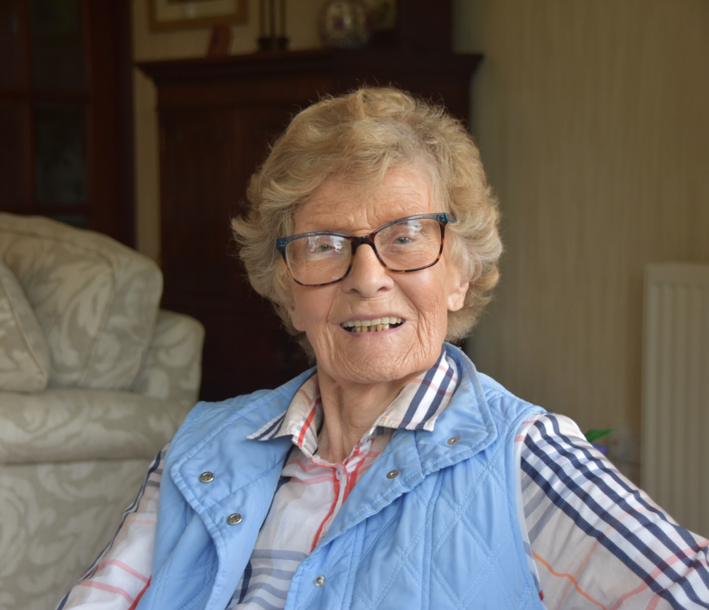

The Doodlebugs were launched from Calais and aimed at London.
“It was the first missile ever and several of them were sent over each day and night.”
“You could see them quite clearly in the sky, with very small wings and a flame coming out the back. They sounded like
motorbikes, and I hate motorbikes for that reason. If the engine stopped, you knew they were nose-diving, or they would glide.
“Although they were aimed at London, many ended up dropping in Kent.”

Biggin Hill Ops Room
Due to damage from aerial bombing, the Operations Room at Biggin Hill aerodrome moved to a large country house near
Farnborough, which had been altered into the new ops room.
Jean and her fellow clerks were billeted near Farnborough, in a lovely bungalow.
“We did day shifts at the Ops Room, and also night shifts.
You did nightshifts for a spell of time. You were supposed to sleep in bed all day, but you never did.”
The Biggin Hill Operations Room looked just like its portrayal in movies. A large table-sized map of South England took up the
centre of a room, and senior officers stood one level up, looking down on the map from inside a glass box.
As Jean describes: “There were several of us on each shift, and
our job was to pick up reports from the Royal Observer Corps.
For example, I’d hear ‘Flying bomb, bearing 625’. I’d listen for
reports from two other Royal Observer Corps and when the three points joined, that was the missile’s position.
“We would push the arrow markers about on the map, to give the position. The sticks had magnets at the end, which the arrow
would stick to. You’d release the arrow by lifting your thumb up [which removed the charge from the magnet].”
“The controller would call up the Spitfires to intercept the
Doodlebugs. Once it had passed over us, there wasn’t much you could do.”

Jean remembers reports of incoming Doodlebugs being quite frightening.
“When we heard a report of a Doodlebug coming, we’d put our helmets on and hope for the best. You just took it in your stride.
Everyone was in the same boat. I think my upbringing had been, you had a number on you. You had a time you were
born, and there was a time you would die. That was the attitude
I’d had.”

A time of service
Many of Jean’s family and friends played a part in Britain’s war effort, either in a reserved occupation or in the Armed Forces. Jean’s future husband Jim and her brother Douglas both served in the Royal Navy– and both served on the Arctic runs.
As Jean describes: “Jim was on the worst voyage which went up the Norwegian Sea and Arctic Ocean to Murmansk in Russia.
But Jim was lucky: he never got his feet wet. Jim never got torpedoed. Douglas was on a corvette called Rhododendron. My other brother, Noel, was a Chaplain in the Black Watch.”
“Jim and I weren’t married then; we just knew each other. He was demobbed before I was.” 0800 035 6409.

After the war
As the tide of the war swung in favour of the Allies, Jean and her fellow clerks were no longer needed at the Ops room.
But Jean took on a new responsibility: “They asked if I’d like to go into the Met Office. They asked, ‘Have you got a strong
mathematical mind? We were fibbers and said ‘Of course!’

“I spent the rest of my RAF career doing forecasts for pilots flying over to Goose Bay in Canada, until I was demobbed in October 1946.”
Jean lived in Edinburgh with her husband, Jim, and had a happy marriage. In 1996, she moved to Dowding House in Moffat,
which was sheltered accommodation for RAF veterans and more recently for veterans from all of the Services. She now lives in Moffat with a family member.

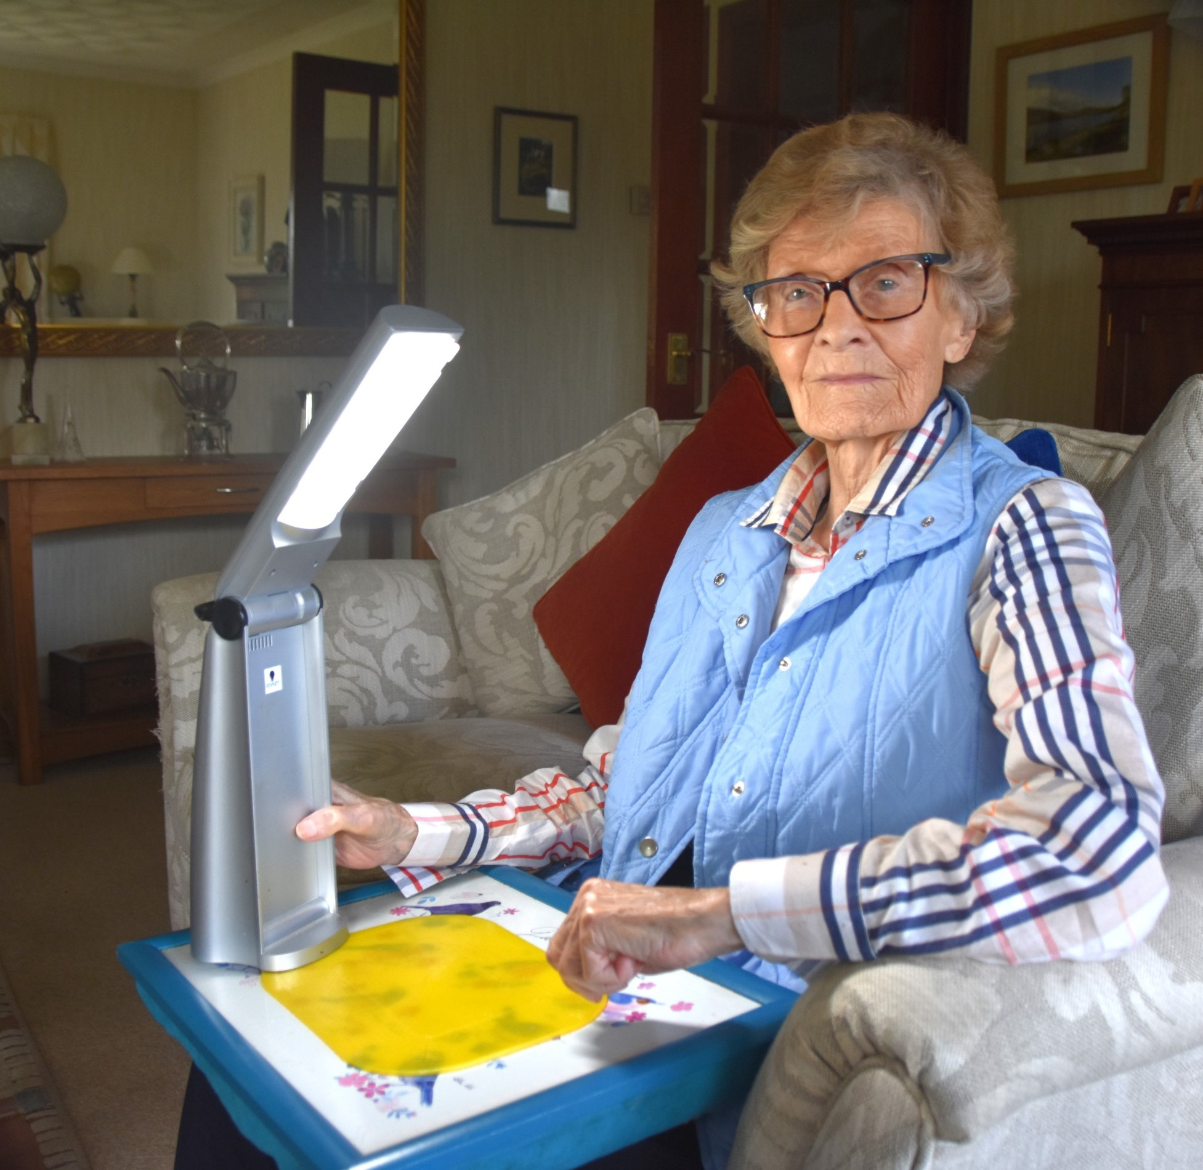

Equipment from Sight Scotland Veterans that’s making a difference
These days, in her 99th year, Joan experiences macular degeneration, which severely impacts her sight.
Jean explains: “I don’t see faces properly. I can’t see details, but I can still see them. Before I heard about Sight Scotland Veterans, reading was difficult. It became a trial doing my
crossword. And reading my newspaper, that’s what I missed.”
However, now the former RAF clerk uses practical equipment supplied by Sight Scotland Veterans to mitigate the challenges her macular degeneration causes her. She uses an electric
magnifier called the Explorer 6 to read letters and the TV guide.
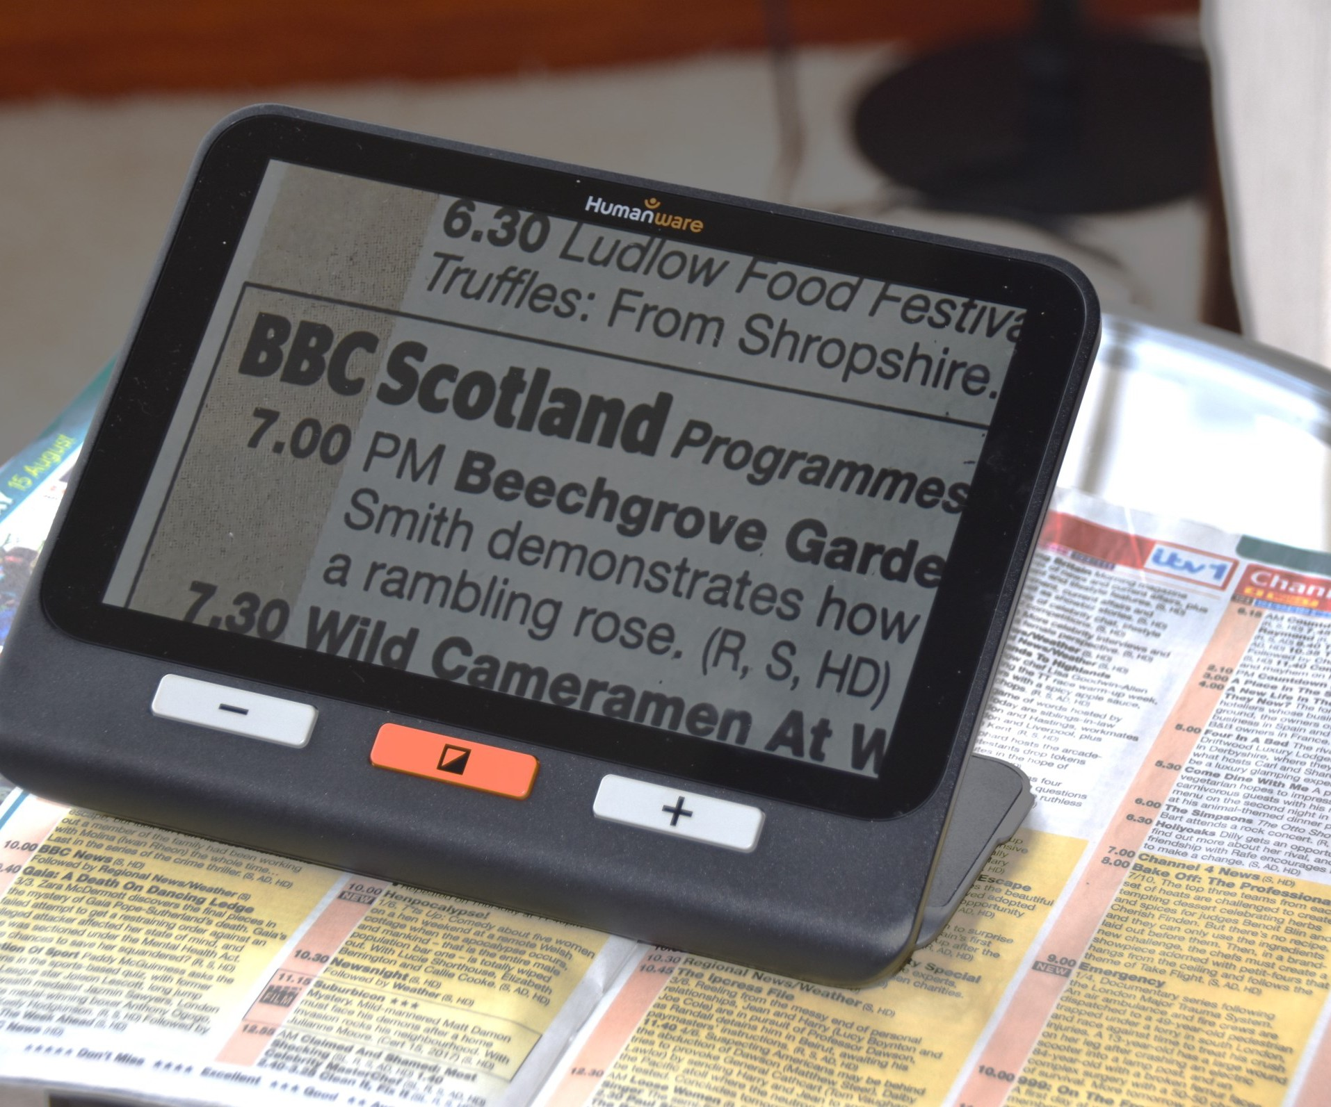

“I use a lamp for supper at night, because the more light I have, the better I can see. I have a better idea of what I’m eating,” Jean says.
21
Jean uses a special one-cup water kettle appliance, which helps prevent spills and burns.

“You just put your cup under the one-cup kettle and push a switch. It pours exactly one cup of boiling water. So you don’t have to worry about boiling water spilling over, when you’re making a cup of tea. These have all made a tremendous difference to my daily life,” she says.
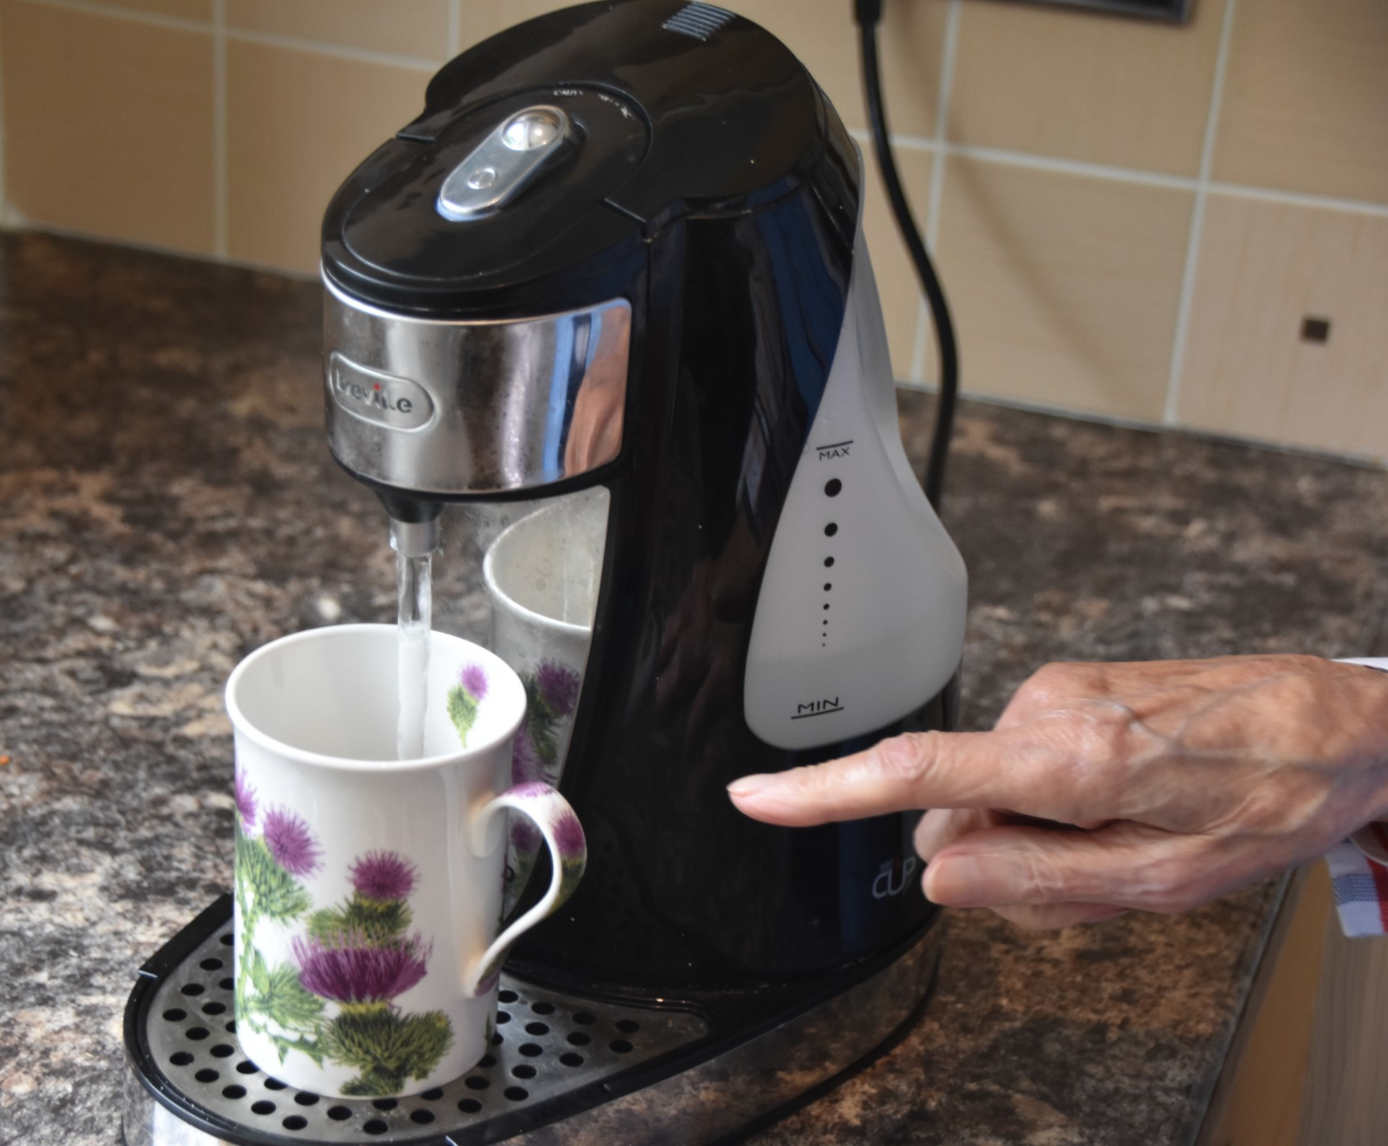
Caption: Jean’s one-cup kettle, pouring the exact amount of boiling water to fill a cup of tea.

Memories
Jean sometimes reminisces about friends she made during the war – friends she kept for life.
“We were Fighter Command 11th Group, in the south of
England, in bomb alley. Friendship was the main thing getting through the war. I don’t remember one of us having an
argument.
“All of us had one thought at that time, and that was, to win the war. Several of my friends lasted until their late 90s.
They were very good friends who lasted a lifetime with me. We were a delightful crowd of girls and we all got on very well indeed,” Jean says.
Reminiscing about the war, Jean shares that she feels very honoured to have worked for Lord Hugh Dowding, Head of Fighter Command, and Sir Winston Churchill – both of whom she admired enormously.
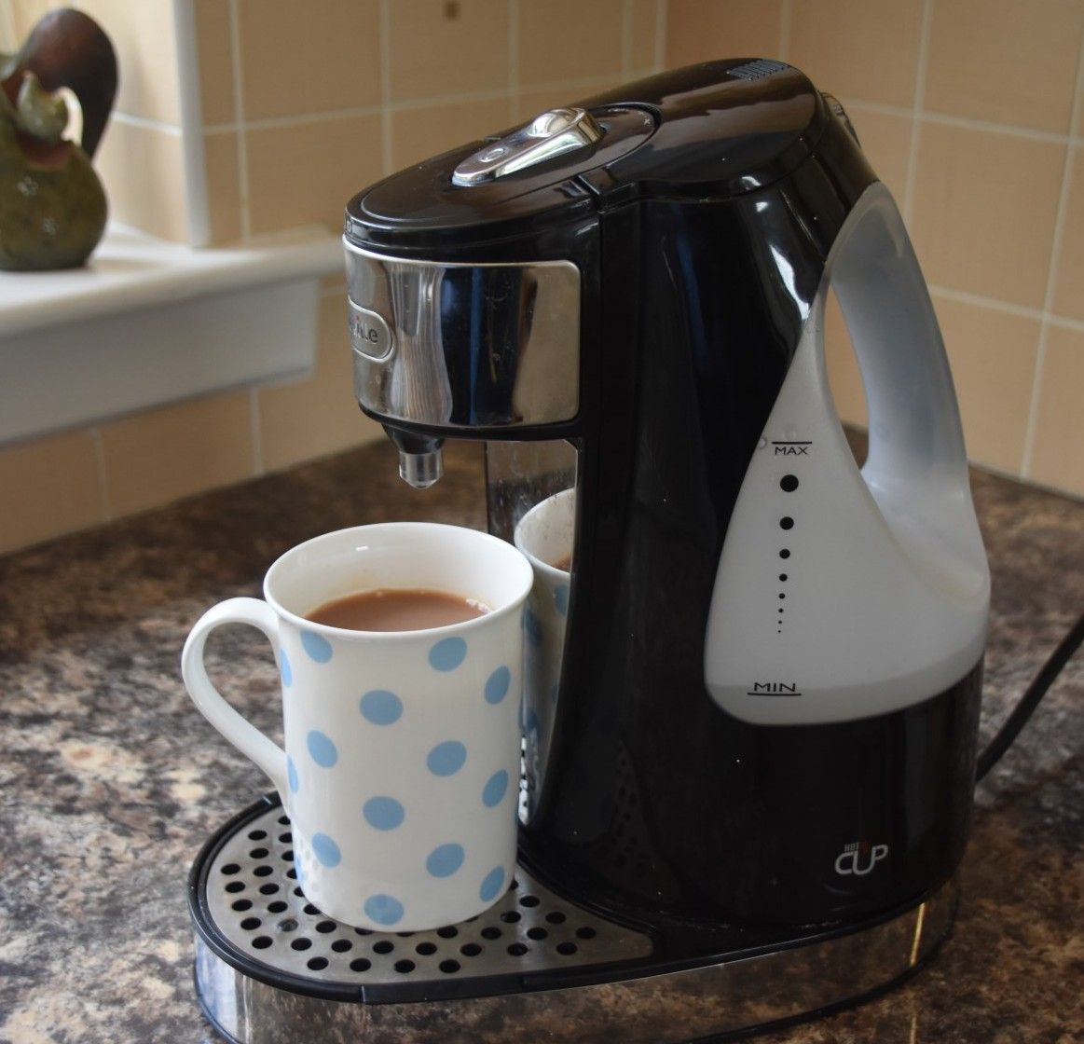

Veterans’ Stories

Army nurse conquers the West Highland Way with aid of binoculars

In 2014, Noreen Smith lost most of her sight in her right eye. Three years later, despite injections for macular degeneration, her left eye also became severely limited.
Now in her 70s, it would have been easy for Noreen to sit back and avoid major challenges. But the keen hillwalker from Glasgow was determined her sight loss would not stop her from enjoying her favourite treks.
Noreen – an army nurse in the 1970s – has continued to climb and ramble her way around Scotland. She uses walking poles to gauge the paths, a magnifying glass for directions and a trusty set of binoculars to read signs.

Inspired to tackle the West Highland Way
Noreen’s can-do spirit was particularly evident this year when she took on the West Highland Way. It would be a decent
challenge for people a few decades younger than the
77-year-old. But Noreen, from Glasgow, focuses entirely on the beauty and fun of the walk – steep ascents and wild goats included.
The former nurse completed the West Highland Way in nine
days, walking with her friend Valerie, and her sister, who joined for later stages of the trek.

Challenges on the walk
The first leg of the West Highland Way took them to picturesque Drymen before a trek up the shores of Loch Lomond through
Balmaha, Rowardennan and Inversnaid, then on to Inverarnan. Noreen said the walk was difficult from Inversnaid to Inverarnan
“That part of the West Highland Way has a lot of big rocks and scrambling. It was the biggest challenge because of the rocks and my eyesight. Trying to stick to the paths was difficult
because people make their own wee routes. At that point, I was walking about one mile an hour.”
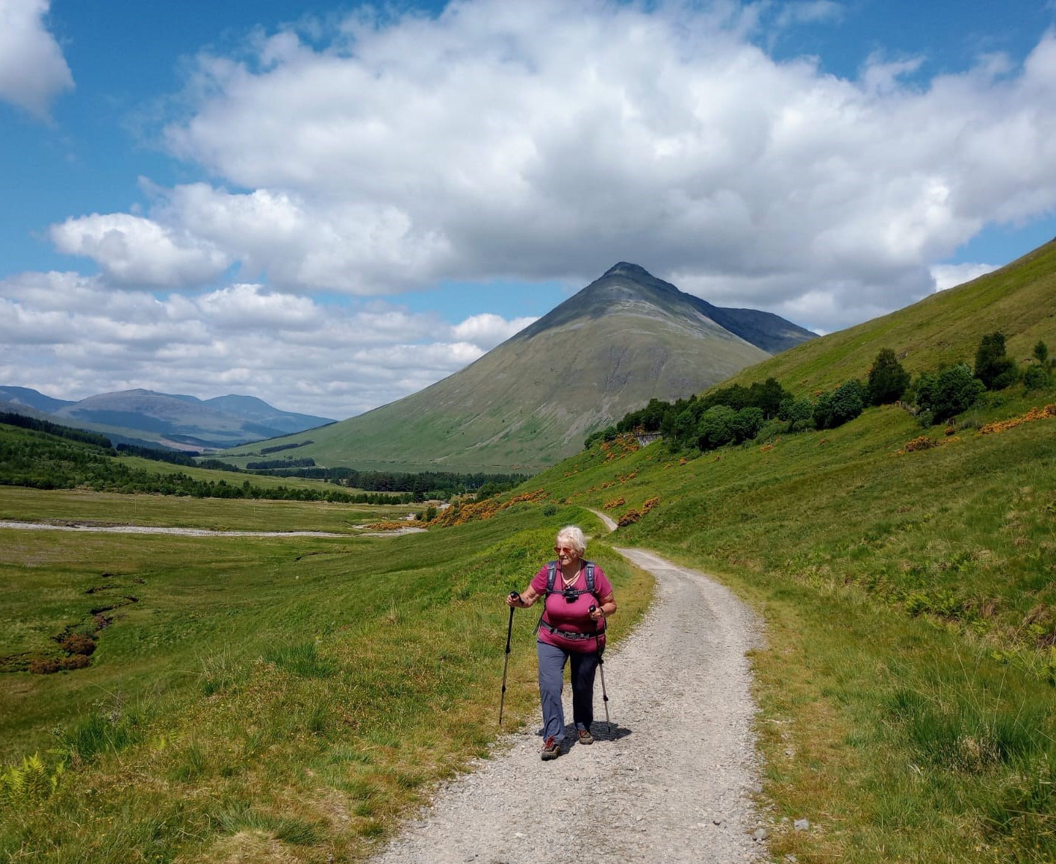

Noreen and Valerie didn’t reach The Drovers Inn at Inverarnan until 8.30 pm after starting out at 8 am that morning. She adds that she was “so tired I didn’t feel like eating”. But it was here that she came across those surprise fellow explorers.
Noreen says: “There were wild goats. Normally you don’t see them but they were out on the trek grazing. We were told that in Rob Roy McGregor’s day, goats lay in front of a cave he was hiding in nearby and the soldiers had walked on by, so now they’re protected. There was a Swiss couple who were a bit
worried. They asked if they would attack them but I said, ‘Not at all, feel free to walk right past them’.”

The Devil’s Staircase
Another highlight of the walk was the climb up the Devil’s Staircase, as they made their way from Glencoe to Kinlochleven.
Noreen remembers: “It was lovely up there. The views were
terrific out over Glencoe and we got some very good pictures of the Buachaille Etive Mor with the rising sun on it.”

Using equipment on the walk
Our Sight Scotland Veterans teams helped Noreen to plan the walk, and also supplied equipment.
Noreen said: “They gave me binoculars which I used along the way. [The binoculars] were excellent and helped me to pick out some of the paths. They were also good for looking at the signs along the way.”

“They also gave me two magnifiers for reading. There’s a small one that’s good for looking at maps.”
Not one to rest on her laurels, Noreen has more treks in the pipeline. She said: “I try and go out every weekend. If things work out next year, I may try and do the Rob Roy Way from Drymen to Pitlochry. I’ve got a friend who has given me the information on it. It’s about 80 miles. I’ve also got some information on The Hebridean Way.”
Would you like to get more exercise and take on an activity? Our new Sports and Partnerships Workers David and Judith are here to help you get involved in sports and exercise — read more on page 34.
To reach David and Judith, call our team and leave a message for them on 0800 035 6409.

Creative Corner

Poems by REME Veteran Colin Weir

In this edition, we have poems written by Colin Wilson. Colin served in the REME, servicing 10-tonne armed vehicles, for three years. Since the army, he has lived in Aberdeen and
Edinburgh, and worked for Edinburgh Council. We hope you en- joy his poems.

Refuge
I seek refuge in my marrow hoping love can't break bone

for love
easily breaks my heart every time
it leaves my ribcage

I always forget the price
of throwing out my
unwanted love

invisible
bruising that aches with each breath taken.

Heart Always There

Crawl into
my heart, lay
fetal style

I will let you
heal here within its soothing beat

scream kick
if necessary
its padded walls will absorb
your heart

just don't
abandon me like all those others I let heal here.

Tips and Tricks

Meet Alexa: Getting to know your Voice Assistant

By Jason MacMillan, Assistive Technology Lead
Today we are surrounded by technology which is transforming the lives of people with sight loss. Smart speakers like Alexa offer amazing possibilities to help build independence and overcome barriers in everyday life using just your voice. They
can give entertainment such as news, music, radio, audiobooks, and podcasts just by asking. This simple and affordable tool does so much, including letting you call friends and family.
In this article, we provide an overview of Alexa and then list some popular ways you can use it.

So, what is Alexa?

Alexa is a voice-controlled digital assistant. It responds like a real person, answering questions and performing the
commands you give it. For instance, it delivers weather
forecasts and plays your favourite music, all through voice commands, so just ask Alexa!

Accessibility built in with no fuss

Alexa devices are very well designed for accessibility. Once it is set up, there is no need to use buttons, dials, or screens,
making it ideal for those with sight loss. You just need to be within speaking range of the device.

Daily tasks made easier just by asking

Alexa helps with various tasks, from creating shopping lists to cooking assistance. In the kitchen, ask Alexa for recipes or set
timers. If you have an Alexa with a camera, you can hold up things like cans and packets and it will read the label.
You can get the news, the weather, when the bus is due, even
add reminders for taking medication and appointments.

You can also use Alexa to control other smart devices in your home if you link Alexa to the smart device. For example, you
could adjust the heating, turn lights on and off and so much more.

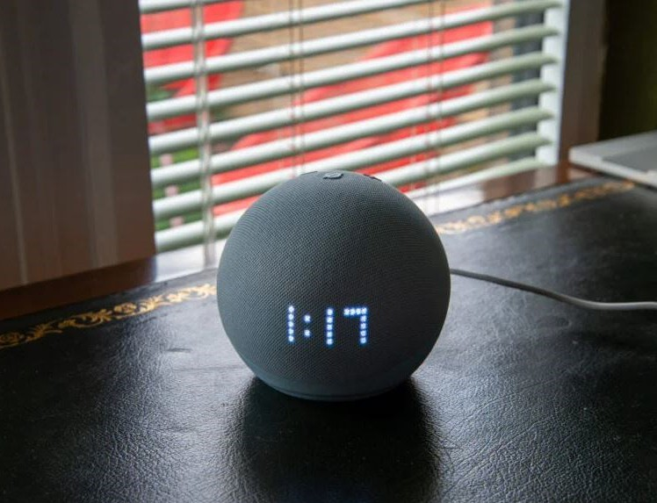

Eight things you can ask Alexa
Alexa will start listening for a command as soon as it hears you say ‘Alexa’. Here are eight tried and tested commands.
Say:

- “Alexa, set a 12-minute timer for cooking frozen pizza.”
- “Alexa, play smooth jazz.”
- “Alexa, find me a podcast about World War Two.”
- “Alexa, play the latest BBC news update.”
- “Alexa, increase the volume.”
- “Alexa, what is the weather forecast for Dundee tomorrow?”
- “Alexa, remind me at 9am every day to take my medicine.”
- “Alexa, what time is the next bus to Edinburgh?”

You can explore different commands with Alexa: you might be surprised what Alexa can do!

Alternatives

While Alexa is an outstanding product with high levels of
accessibility, there are other digital assistants and smart speakers in the market that can also help and do a similar role.

Get Involved

A survey about technology and sight loss

You are invited to give us a call and take part in our survey on the types of technology you use. The number to call is 0800
035 6409.

Introduction

In today’s world, we are surrounded by technology that can help when living with sight loss. Computers, laptops, phones, tablets, and smart speakers are just a few of the electronic
items you may already use. They have the power to overcome some of the challenges you face every day. Often, however, people have these things and don’t realise the full range of the help they can offer. Our mission at Sight Scotland Veterans is to help you live well with sight loss, and unlock those options for
you.

The benefits of technology

Electronics can help with important things like connecting you with friends and family, colleagues, and even people you served with. You can look up regimental or service pages, order
groceries to be delivered, get audiobooks, and listen to music or the radio, to name but a few ways it can help.

Why this survey is important

We are developing a strategy to tackle the issues around using technology and to help make things easier by giving the right
training and support to help you use it to overcome some of the barriers you encounter in everyday life. The strategy will make sure we are ‘getting it right’ with how we support and
encourage you to use it confidently.

We want to hear your opinions

The following questions are about technology, how you use it, what kind of support you need with it, and any suggestions you want to share with us. Even if you don’t use technology, we still want to hear from you. Please call us on 0800 035 6409 to speak with our team and share your experiences, answering the questions below.
Survey Questions:

Question 1: Do you currently use any kind of technology? If so, tell us what it is, and how well it works for you.
Question 2: If you do not use technology, or have problems with it, tell us what the barriers are, and what we might be able to do to help.
Question 3: How confident are you with your skill levels in using technology, and how could we help build those skills?
Please call us on 0800 035 6409 to share your answers. Thank you so much, we look forward to receiving your call.

Get Involved

Take part in a podcast about your transition to Civvy Street

Do you wish someone had told you more about financial matters on Civvy Street before you left the Armed Forces?
Forces Children Scotland and Sight Scotland Veterans invite you to participate in a series of podcasts to help families about to leave the Armed Forces. We know making the change from
military to civilian life is challenging. This podcast series explores the lived experiences of veterans like you, and provides advice and tips, helping families prepare for the financial matters they’ll encounter on Civvy Street.
We’d love to hear your experience and for you to get involved. Please help make things easier for families leaving the Armed
Forces in the future. If you would like further information or are interested in taking part, please contact Sight Scotland Veter-
an’s Lorraine Bruce on 0141 370 8050.

SSV Updates

New opportunities to get involved in sports

Want a burst of good mood and better sleep at night? It’s time to get some exercise or play a sport!
Physical exercise does wonders for your mental health, in addition to your fitness and general health. Whether you’re
lifting bowls and sending them towards a jack, swinging a golf club, or walking with a group, it all makes a difference.
Good news is, we have two new staff members dedicated to helping people experiencing sight loss, like you, to become more active. David Macleod and Judith Crawford are our new Sporting and Partnerships Workers.

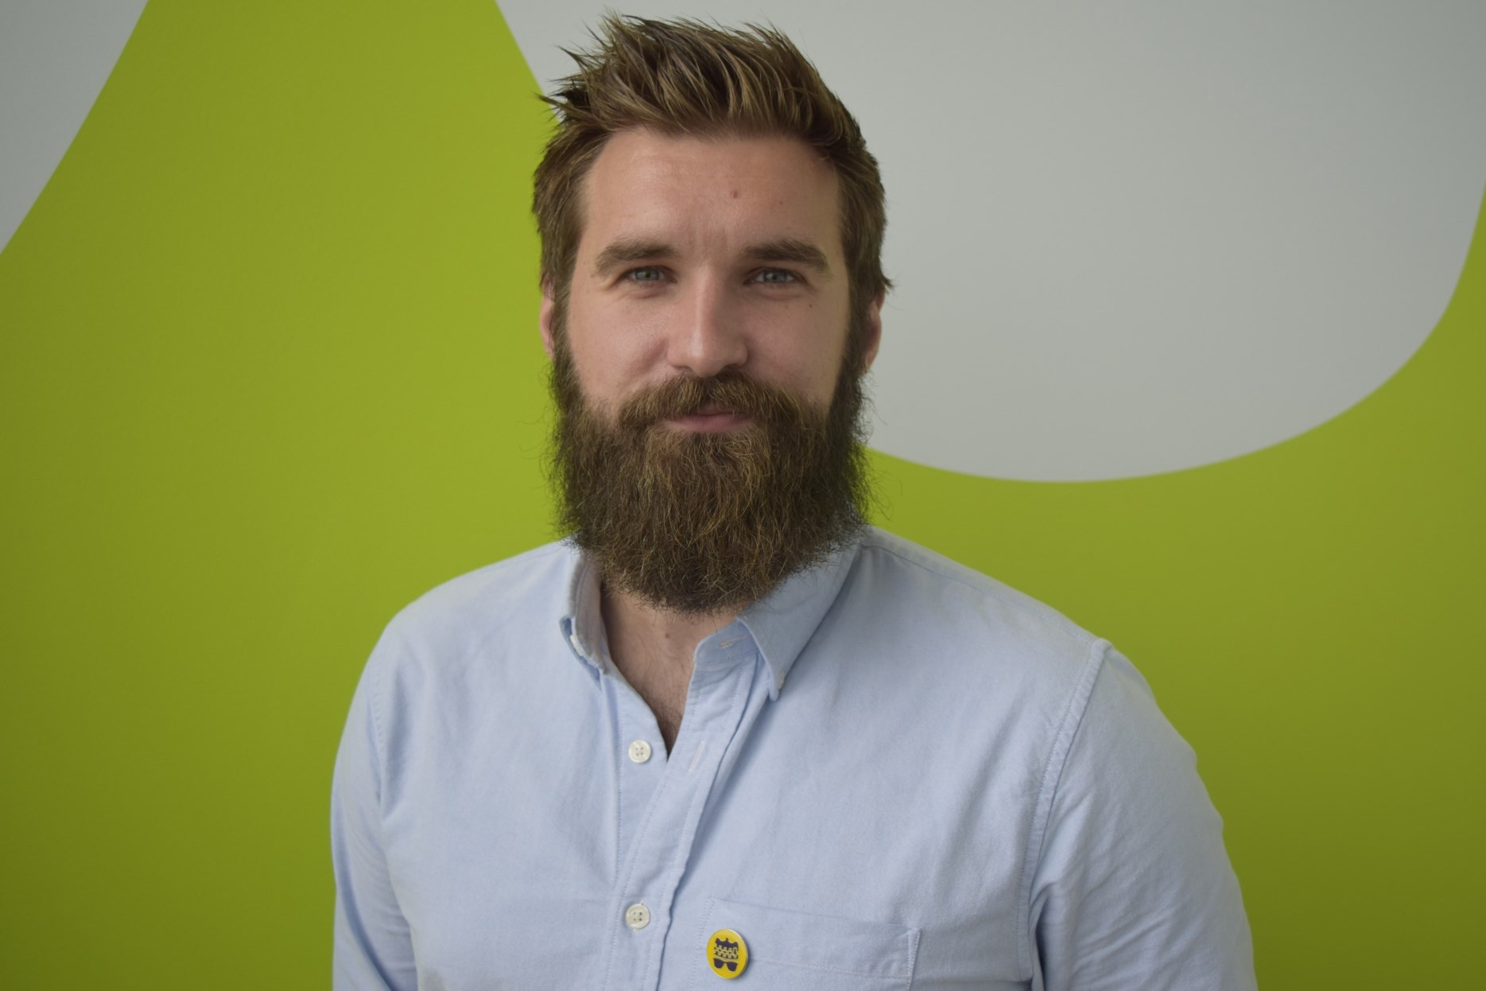

David and Judith are both working in areas away from our Activity Hubs, the Linburn Centre and the Hawkhead Centre. Judith is based in the north of Scotland, while David is working in the central west, as well as the north. They are both visiting
organisations and sports clubs, investigating ways to offer more sports and exercise for people with sight loss.
David said: “You might have thought there were too many barriers to getting involved in sports.
“There are challenges, but we are building up the options for you. We are finding ways to make it happen.”

David says opportunities exist, even in busy areas.

“I get that some clubs are busy and competitive, but there are many hours in a day. There will be times that bowls lawns aren’t being used, for example, and we can have a fun social session, with a bit of support.
“It’s about what you can do, in the community you live in.”

If you would like some help getting involved in sports or other physical activities, please do give Judith and David a call through the Sight Loss Information Line: 0800 035 6409.

SSV Updates

You can receive our easy-listening audio magazine

Do you enjoy easy-listening audio books? Our team have been recording some relaxing activities, and we invite you to listen to
them. You can receive our Wellbeing Audio Magazine recordings on a USB stick, delivered to your home, which you can pop in a USB player.
Our latest recordings reflect an autumn theme, as the days grow crisper. We have a description of how to cook a braw bowl of French onion soup; a poem on the theme of autumn; and instructions on physical exercises that you can do sitting down – no need to venture outside, if it’s dreich!
The autumn audio magazine also has a riddle (the answer is provided at the end, don’t worry), and a bit of information
about a sight loss condition, diabetic retinopathy. Past audio magazines have included a colourful description of a veteran’s particularly glorious garden and a narrated walk along Wardie Bay, on the edge of the Forth of Fife.
If you’d like to receive this audio magazine – and future editions – in USB format, please call our pals at the Sight Loss
Information Line on 0800 035 6409 and tell them you’d like to join the mailing list for the "Wellbeing Audio Magazine".
Happy listening!

SSV Updates

You could be eligible for our 2024 Winter Grant

Our Financial Wellbeing Service is providing tailored, targeted
support where it is most needed. Given challenges with the cost of fuel, we are offering a grant of £150 this winter. This will be paid in January 2024 to assist with the cost of heating.

Are you eligible?
You could be eligible if you fit either of the following criteria. The criteria are, firstly, if you spend more than a quarter of your income on utilities (power, gas). Or, secondly, if you
receive a benefit. More details are below.

Receiving a benefit
You may be eligible if you are in receipt of at least one of the following benefits:
- Income-based Jobseeker’s Allowance
- Income-related Employment and Support Allowance
- Income Support
- Pension Credit
- Tax Credits (Child Tax Credit and Working Tax Credit)
- Housing Benefit
- Council Tax Support
- Universal Credit

Spending one-quarter of your income on bills

If you are spending more than one-quarter of your income on utility bills, you may be eligible for this grant. This situation is given the term of “fuel poverty”. Please get in touch if this
sounds like you.

Supported by Sight Scotland since before September 2023

Finally, this grant is for anyone who had already joined our
organisation, Sight Scotland Veterans, before 1 September 2023.

How to apply for the £150 Winter Grant

You can apply for the grant between now and 31 December 2023 There are two ways you can apply for the grant:
- Call us on 0800 035 6409. Our Sight Loss Information Line team will ask you for details and complete the Winter Grant application form with you over the phone.
- Speak with a member of our staffing team in person, and they can complete the Winter Grant form with you. This
could be an Independent Living Worker visiting you, or staff at the Hawkhead Centre or the Linburn Centre.

You can contact us

Our Financial Wellbeing Team are only too happy to answer any queries you have about the grant, so feel free to call 0800 035 6409 to book a time to speak with our team.

SSV Updates

Our Policy team’s recent campaigns

Our Policy team is working to make Scotland a fairer society for people with sight loss by campaigning to deliver positive
change. Here are some recent highlights from our Policy team’s
work.

Improving Telford Road junction
A user of our Sight Scotland services who is impacted by visual impairment told us about a junction in the Craigleith area of
Edinburgh which has no audio signals or revolving cones at the pedestrian crossing. Our Policy team met with the local
councillor, Hal Osler, to investigate and discuss the next steps. Following this, our Policy Team met again with Councillor Hal Osler, and also with Alex Cole-Hamilton MSP, to discuss this
junction. We are currently waiting on a response from
Edinburgh City Council to help us decide on the next steps to make this crossing safe.

Tactile paving on train stations
Our policy team received feedback from someone who arrived at a railway station that didn’t have tactile paving on the edge of the platform. The person, who has visual impairment, was unsure where the edge of the platform was. We are very
concerned that not all stations in the UK currently have tactile paving. In August, we met with Owen Thompson MP and Colin Beattie MSP to discuss this issue. The person with visual
impairment attended the meeting too and shared their
experience. 42

We were pleased that both the MP and the MSP were very
supportive of our call to urge both the Scottish Parliament and Westminster to treat the introduction of tactile paving as a
matter of urgency. It has been announced in Westminster that tactile paving will appear in all mainline railway stations in the UK by the end of 2025 at the latest, but we want to see action immediately. Transport accessibility is a policy we will continue to campaign for.

Street obstacles

An issue we’ve been investigating in recent months is the accessibility of streets. As you might’ve experienced, unusual and unexpected obstacles on the footpaths can make it very difficult to get around – unseen obstacles can cause injuries!
With this concern in mind, our Policy team has been working to
make streets safe and accessible. In July, we backed a
week-long campaign by an organisation called “Living Streets”, which called on councils to remove obstacles from streets.
Examples of obstacles cited were road works, A-boards,
overgrown hedges, and street furniture. We’ll continue working with partners to raise this issue including Edinburgh City Council and their plans for the redesign of key parts of the city.

Get in touch

If there are any policy-related issues you’re facing, please don’t hesitate to get in touch. You can call the Sight Loss Information Line and leave a message for us to contact you, or email
policy@sightscotland.org.uk.

Thank you for reading the latest edition of The Bugle.

We promise to keep your information safe and will never sell or swap your details. If you change your mind about receiving newsletters, please email hello@sightscotlandveterans.org.uk or call 0800 035 6409.

End of document.

