Autumn 2022

Sight Scotland

Veterans
Tackling vision loss together

sightscotlandveterans.org.u

Contents Page
A message from Clair Bryan, Director of Services 3
Veterans’ Stories
Jim the Countryman: How archery became a uniting force 5
Latecomer to bowls competes at blind bowls finals 19
Blind golfer travelling to world famous course 23
Tips and Tricks
Smartphone apps that instantly read text aloud: Seeing AI
and Envision 26
How to check validity of phone calls from the bank 32
Get Involved
You can help develop services for veterans with sight loss …34
Sight Scotland Veterans Update
Our 2022 Winter Grant 35
News in Brief
Veterans encouraged to share views on the ban on
homosexuality in the Armed Forces prior to the year 2000…37

A message from Clair Bryan, Director of Services

No matter what age you are, Autumn can still invoke a ‘back to school’ feeling. Along with a crispness in the air and the leaves starting to brown, it brings a feeling of newness and purpose as we review the year so far and prepare for the winter ahead.

Summer has been busy for us at Sight Scotland Veterans. You may have
bumped into our Independent Living team, who have been out and about
across Scotland attending local veterans groups, low vision clinics and other events.

Community engagement like this is extremely important as it means we can connect with others in the veterans community, raise awareness of the support we provide and reach more people who could benefit from our help, just like you.

We’ve also been planning for our new advertising campaign, which you may spot in the Autumn months, promoting Sight Scotland Veterans.
Thank you to our Members Councils, who took the time to give their thoughts on this campaign.

Through the campaign, we hope to reach more veterans at earlier
stages of their sight loss journey – something we promised to do in our Sight Scotland Veterans strategy. We know that early intervention and support can make a real difference in slowing the impacts of sight loss.
We can help people to access the equipment and build the skills they need to live confidently and as independently as possible. It’s exciting
to see the plans we laid out in our strategy turning into actions like this.

Looking ahead at the next few months, we will of course be making plans to commemorate Remembrance Day in November. Taking the
time to remember the sacrifices made by all of you in the Armed Forces community is so important to us.

I always enjoy reading the stories from our veterans in The Bugle and learning about your experiences both past and present. In this issue, one veteran tells us about his long love of archery and the outdoors.
Another veteran shares how his newfound love of bowling led him all the way to a national championship.

It’s a privilege to hear, and share, these stories. I hope that you enjoy this issue, just as much as I have.

Take care,
Clair Bryan
Director of Services Sight Scotland Veterans

Veterans’ stories

Jim the Countryman: How archery became a uniting force

When it comes to archery, RAF veteran Jim McPike has more experience than most. Jim, now 91 years old, has been
shooting arrows since he was young.

“I’ve been doing archery all my life,” Jim said.

“When I did my National Service with the RAF, I was posted to a training camp at Moreton-in-the-Marsh, on the edge of the
Cotswolds, and I trained as a Medical Orderly. I had a bow and I used to go into the woods and practice.”

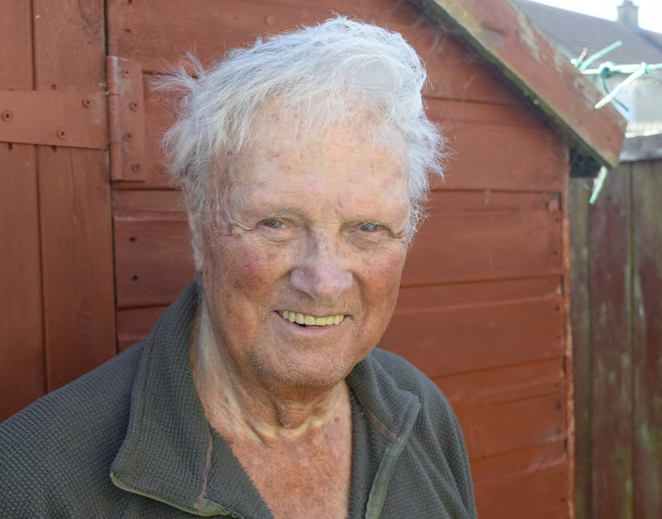

Jim, who has macular degeneration, learned to hunt small game with his bow.

“We used to shoot rabbits in open fields, places with small
hillocks, where their burrows were. You’d have to be patient, sit and wait, because when they see you, they’re off.

“If you get within 20 yards, you have a good chance of hitting a rabbit. You’d aim for its body. I’d use an arrow with a wide, wedge-shaped arrowhead. When you hit them with a wide
arrow, it cuts as it goes in and kills them instantly.

“Alternatively, if you use an arrow with narrow point, the
narrow-pointed arrow would go straight through them. They would run off and then die someplace else, much later, which isn’t nice.”

Jim would take the rabbits home and cook them.

“I’d skin them at home and cook them whole. I’d add vegetables and make a stew. I’d also hunt pheasants and they’d go in the oven.”

Jim would make his own bows using yew or ash wood. He has about 50 bows in his shed and is now donating many of them to archery equipment at the Hawkhead Centre, for other veterans to use.

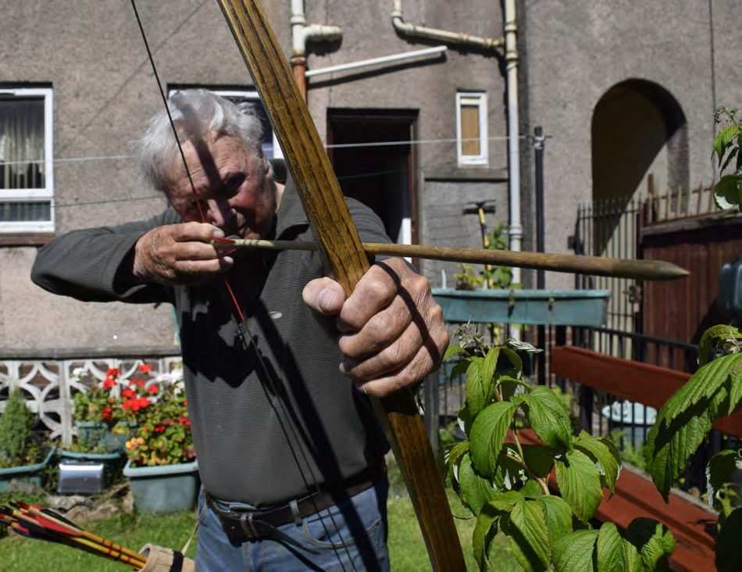
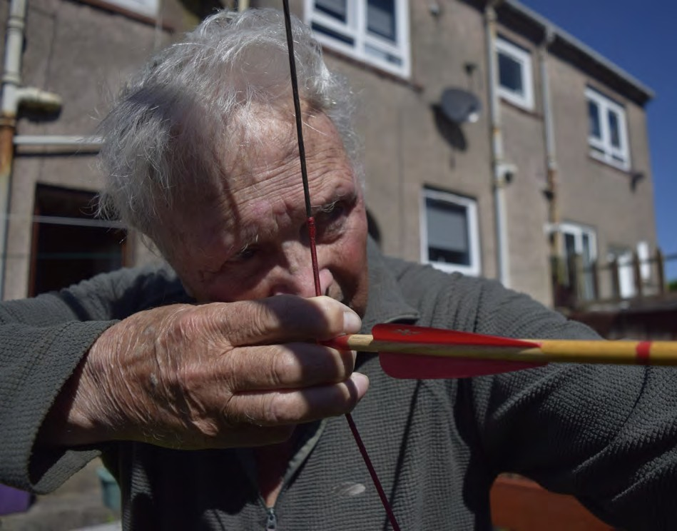

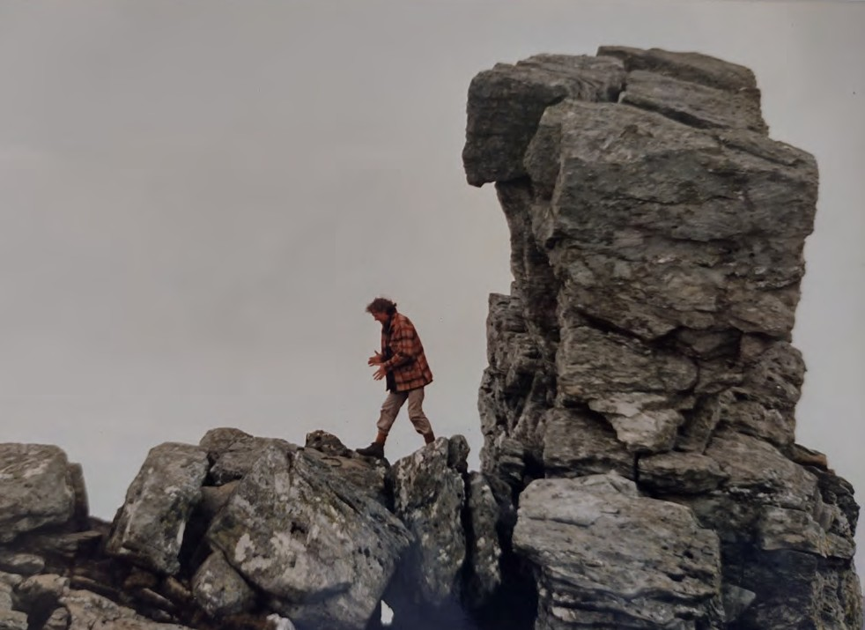

Wanting to share his hobby, Jim helped set up an archery club for young people in his local area, Kilmarnock, many years
ago.

Jim said: “Weans were running about here and getting into bother. The excuse given was, they had nothing to do. We had a meeting and they asked if anyone had skills to offer which the children might be interested in.

“I came up with the idea of an archery club. The first day, so many people turned up that we could only give each kid three arrows. It was a fantastic success and it became the North
West Archery Club.”

In 1982, Prince Charles was visiting Kilmarnock and he visited the North West Archery Club.

Jim said: “We had a good chat and I gave him a shot with a bow that I’d made. We got on great together.

“Prince Charles asked me, ‘What possessed you to start a club like this?’

Jim said: "I want the kids around here to experience the
outdoors. When you go to the woods nowadays, you don’t see any kids at all. That’s a shame, because they’re missing out on a quite a lot. Learning to shoot an arrow gives them a taste of the outdoors.”

“I’m a country guy and archery, hillwalking and fishing have always been my main events. When I was a boy, we used to go up into the woods. We’d make a raft and go swimming in
the loch. We would make a fire and we’d throw tatties into the fire to cook them. They came out black, but you’d just pull the skin off them, and eat them.

“Prince Charles said, ‘Oh, I did that too, with my brothers up at Balmoral’.”

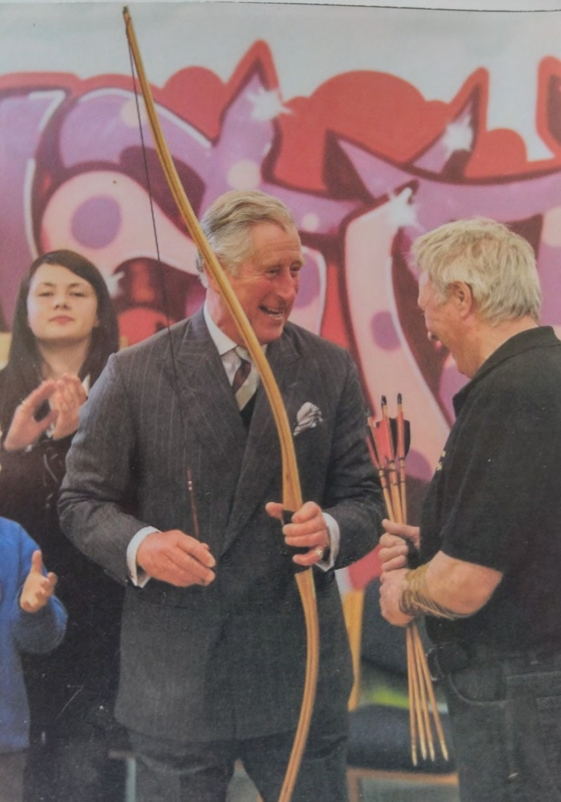

To start the archery club in Kilmarnock, Jim taught the sport to a handful of youth workers over six weeks. Those youth workers became archer coaches at the club, who ran classes for children aged 5 to 14 years. The North West Archery Club continues in Kilmarnock today.

Jim said: “I was proud I got it going because nobody thought we’d be able to do it. A lot were amazed when they saw the turnout we had.”

After his National Service, Jim worked as a welder at Massey Ferguson, a factory which manufactured combine harvesters. He worked there for 27 years until it closed.

“After the factory closed, I started making gates and railings. I worked for myself and I would design them, make them, fit them.”

Jim McPike also became a keeper at a fishing loch, Loch Dunwan. Jim gained the position after working with the previous keeper for several years.

“I knew the keeper quite well. He would never ever give
anyone a day’s fishing. He called me Pikey. One day, I met him in town at an ironmongers. He was looking for half a dozen roll-ups, which are the rings that oars go into on a boat.”

Jim said: “The previous keeper said he couldn’t get the
roll-ups anywhere, so I said to him, ‘How many do you want?’ He was after half a dozen.

“So I made them for him, myself. I took them to him a week later and the keeper asked, ‘What do I owe you?’

“I said: ‘A day’s fishing’.

“He said, ‘You’re a fly bastard, Pikey!’

“I said, ‘That is the price – a day’s fishing – take it or leave it’. He took me out, and the next week and the week after, and we had a great time fishing. He offered me the position of
assistant keeper.

“He said, ‘There’s nae' money in it, but you can do all the fishing you want’.”

Jim was assistant for five years. Sadly, the keeper passed away. Jim took over as keeper and was the keeper for the next 15 years.

“I loved every minute of it,” Jim said.

“One time, I was out at the Water of Minnoch. The midgies were terrible, so I put on a white hood that the spray painters used to use at Massey Ferguson. I had a machete because I was wanting to cut a stick to tie a snare on to. Then I looked across the river and saw a young couple.

“I thought I would have a laugh, so I took the machete and ran it across my neck, miming cutting my throat. They didn’t stick around; they ran.

“I went down to the carpark later without the hood, and the couple was were there. They said, ‘Don’t go down there,
there’s a madman with a machete’. I still laugh when I think about it.”

Another time, Jim was fishing at the River Stinchar, a great salmon water.

“I spotted a guy fishing further down the river and he wasn’t catching anything. I had a look at his fishing line and I
snapped it. I said, it’s a good thing you didn’t hook a fish in because this line would have broken.

“I hooked him a fish and gave it to him, and I left him my rod. He brought it home to me that night and told me he caught two more fish with that rod. He invited me down another day as a guest of a fishing syndicate of four people.”

The syndicate would pay the local farmer a certain amount of money to be allowed to fish at the river running through the farmer’s land.

Jim said: “One day, the father of the guy in the syndicate said he had seen a big fish further up the river, past the point which the syndicate was allowed to fish at.

“His father asked if I could go up the river and hook it for him.
I hooked it and it was a huge salmon… but, when it was on the line, I saw the farmer coming. So I quickly cut the line.
The farmer wasn’t too pleased and said I should have come to him first to ask for permission to fish there.

“Two weeks later, I went into the wee village for a pie and a pint, and they were talking about the big salmon which was caught at the pool. It sounded like someone had been fishing and had caught a line, and then tied it to their own, and
pulled a big salmon which been hooked by the tail.

“When I heard about the tackle, which had a single hook and a piece of lead at the bottom, I knew it was mine and it was the fish I had cut off and let go. So, the salmon I’d hooked
had finally been caught. The big salmon turned out it was 20 pounds in weight. I never saw it, except the tail.”

These days, Jim lives in Kilmarnock.

“I’m 91 now and I’ve had a great life, to be honest, with all the things I’ve done,” Jim said.

Jim said he’d be happy to speak with other veterans who are interested in fishing, hillwalking and archery.

He has also written a poem called “The Life of a Countryman”. You can read this poem on the next two pages.

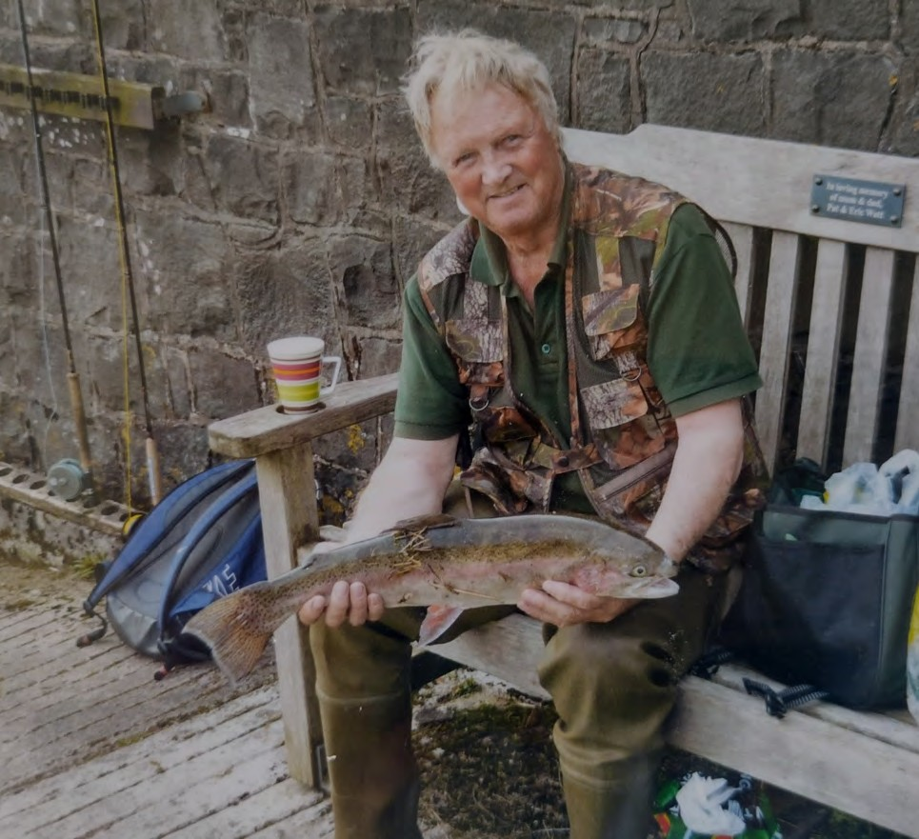

The Life of a Countryman

By Jim McPike

As I lie awake at night in bed I think often of the life I led
Of all the things I have seen and done The dangers that I thought was fun

Mountains climbed that I hold dear To climb no more I shed a tear
The salmon rivers where I poached
The budding archers whom I coached No more will some of these I’ll see Except in dreams and then I'll be
On a mountain top where the eagles fly And watch them soar into the sky
Or in the valleys where the deer herds play Till the stag sensing danger leads them away

Again I am looking in a burn
And see the salmon as they turn To take the anglers gaudy fly
If taken then the fish will die
Keepers baying for my blood
Of salmon poached when rivers flood In clear water I caught them too Hooking more than just a few

With bow and arrow I shot small game For target shooting is not the same
I shot the pheasant, rabbit and hare On private land I did not care
To me it was just all good fun Whether it was with bow or gun
Swimming in cold clear highland water And see the fish caught by the otter Walked on mountains, moor and glens
Sometimes alone, sometimes with friends
I have seen pine martins at dusk and dawn A fleeting glimpse and then they're gone

Alas father time catches up with all But in my life I've had a ball
If I wanted to do anything I'd just do it And never once did I ever rue it
So when I dream it is not in vain I am doing it all without the pain

When I awake I realise The life I led never dies.

Veterans’ stories

Latecomer to bowls competes at blind bowls finals

Less than four years after first taking up bowls, Army veteran Walker Moir has fought his way to the final of the blind bowls national championship.
Walker played both the semi-final match and the final of the B2/B3
category at the National Championship on Saturday 23rd of July.

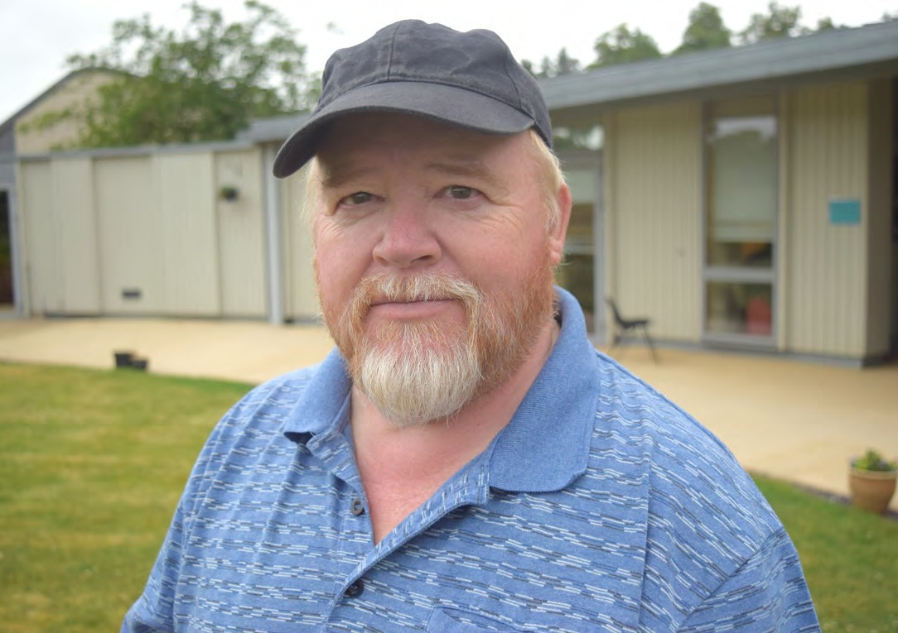
Walker said he was relieved to win the drawn-out semi-final game against another player who plays at Walker’s local club.

Walker said: “I thought I had beat him in two and a quarter
hours when it was 19 points to 3. But it was first to 21 points, so we played on.
“He ended up coming back at me. I stalled on 19 points and we played for another 45 minutes. I was getting panicky when the score was 20-all,” the 65-year-old said.
Finally, Walker scored the winning point on his semi-final opponent.
“He was placing the jack, but he put it out of the rink, so I got the jack back,” Walker said.
“I put it in close, just over the minimum length, and then got two bowls up beside it to win the game – I was quite happy with that.”
Walker competed in the final one hour later against Sandy McIntosh from Inverness. Walker’s friend, fellow Sight Scotland Veteran Ian Graham, acted as his “Director”,
meaning Ian advised Walker on the playing green’s condition and the best strategy to outplay his opponent.
Walker said: “Ian knows Sandy well and he knows how Sandy plays. Ian said, ‘Put a ball at the back because Sandy will definitely aim to get the jack at the back’. It all adds up to a massive help.”

Walker played well in the final but couldn’t outplay Sandy.

“Sandy beat me 21-9. I got the silver medal, which I’m delighted with,” Walker said.

“It was a great day. The layout at North Field Ayr is like
Wimbledon, with a centre pitch that has the best grass and seating around it. There were about 500 people in the crowd. I thought the games would be quiet and serene, but oh no, there was screaming and shouting, just like a football match.”
Ian said Walker played very well to reach the final. “As someone new to visually impaired bowling,
Walker’s silver medal just proves what can be done,” Ian said.

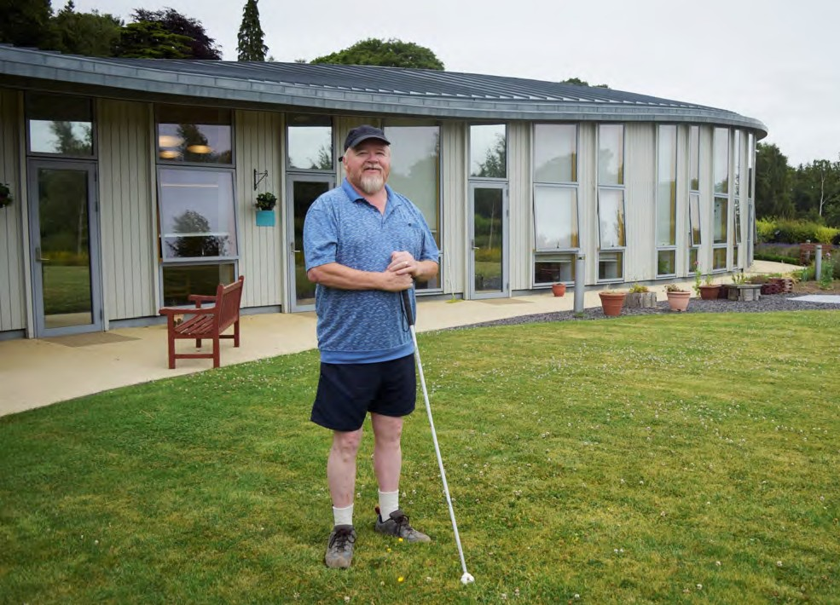

After the final, Walker returned to his local club to celebrate.

He said bowls clubs were very accommodating to blind
bowlers and he encourages other blind veterans to give it a go.

“I am blind in my right eye and have macular degeneration
and diabetic retinography in my left eye,” he said.

“But I’ve played in 16 sighted tournaments at my local club. People go out of their way to help you. Recently, I was paired up with a sighted guy and I said to him, ‘I’m blind, and if you’re not wanting to play with me, that’s fine’.
“He said, ‘No problem at all. I’m quite happy to play with you’. In the two years I’ve been there, I’ve never had a negative comment.”
Walker said that any veterans keen to try blind bowls should contact their local club.
People wanting to find out more about blind bowling can also contact Ian Graham, Secretary of Visually Impaired Bowlers Scotland, on 07308 666232.

Veterans’ stories

Blind golfer travelling to world famous course

The world’s best blind golfers will soon take aim at Florida’s TCP Sawgrass – and Stonehaven veteran Ally Reid will be taking his best shot too.
Ally was selected to play at the 2022 ISPS Handa Vision Cup in late September against seven other blind golfers in the B3 category. This follows Ally’s performance at the British Blind
Open in July, as previewed in the summer edition of The Bugle.
Ally, 73, said TPC Sawgrass was a “bucket-list course”, and he was looking forward to the 17th hole.
Ally commented: “The 17th is the iconic island green. You’ve got to be able to hit it on to the island, or you’ll land in water. It’s the most famous hole in American golf.”
Sight Scotland Veterans and Blind Veterans UK are jointly
helping Ally to make the trip to Florida by covering 95 per cent of flight costs for Ally and his wife, who is his guide.
Ally, a former engineer who is supported by Sight Scotland
Veterans, said he was astounded to get the chance to play at TPC Sawgrass.
“I’m extremely grateful to Sight Scotland Veterans and Blind Veterans UK for contributing to the cost of flights,” Ally said.

Ally said: “It’s my first time to Sawgrass. You wouldn’t think – except for a blind golf competition – that you’d be able to play it.”
To play blind golf, each blind golfer has a sighted guide.
The guide describes the hole, helps with club selection, and then ensures the club head is directly behind the ball. From there, it's all down to the blind golfer’s swing. A blind golfer’s guide, or their playing companions, watch where the ball
lands.

Ally said learning to play blind golf had given him a great deal of confidence.
“It’s been 22 years since I lost my sight. I know what it’s like. The first six months, I was bordering on depression. Nobody says, ‘Even though you’ve lost your sight, there are things you can do’. But I had a social worker who introduced me to blind bowling.
“When I discovered that people who were totally blind were going bowling, I thought, ‘why am I sitting on my ass here?’
“So I went back to golf. I was initially embarrassed to ask the guys to watch where my ball went, but they’re already watching where the ball goes anyway,” he said.

Next year, 2023, the British Blind Golf Open is being held in
England.

Ally said: ”Any veteran who joins our society, Blind Golf Scotland, will become a member and get the opportunity to play in the British Blind Open and other competitions. People that have never played golf before are more than welcome.”
Ally urges veterans to try blind golf.

“You’ve got to join us,” Ally said. “All you have to do is pick up the phone and phone me up. We can arrange training for you. We’ve got guys who have never played golf before, who are playing now. We can even arrange a loan of golf clubs, if
we’ve got them.”

“If I can do it, anybody can do it. A lot of people are better than me, and a lot of people are worse. You have to try and do what you can.”

You can contact a Blind Golf Scotland organiser in your local district if you are interested in learning more:
- Grampian: Ally Reid, 01569 762 046

- Greater Glasgow: Kris Adams, 07415 693 064

- Edinburgh & Lothian: Charlie Forbes, 0131 477 9007

- West of Scotland: Bennet Ward, 01655 883 859

- Tayside: Barry Hampton, 01382 543 234

Tips and Tricks

Smartphone apps that instantly read out text

Word is spreading about easy-to-use cell phone technologies that read text aloud.

These free technologies are available on both Apple iPhones and on smartphones that use Android software. On an Apple iPhone, the technology is the “Seeing AI” application (app).
The equivalent app on a smartphone that uses Android software is the “Envision AI” app.

To use these apps, open the app and point the smartphone camera at written text. The apps will automatically detect the text and read it out. It works on computer screens and bus timetables too.

Michael McAllister has been using Seeing AI on his iPhone since 2018, after his sight deteriorated.

“It’s empowering people with sight loss, it really is,” Michael said.

“No-one wants to be at a café or a restaurant, and have to ask someone to read the menu to them. I can just say: ‘I have my phone, I’ll put my headphones in and have the menu read out to me’.”

To have text read out instantly, select the “Short text” setting on Seeing AI. This setting is called “Instant Text” on Android smartphones, which use the Envision app.
Michael said: “Short text is for spontaneous transcriptions. It instantly reads out any text that is in the camera frame. That’s
the best one for a paragraph or two of text because it works so quickly. It’s great for reading emails and letters.”
For longer text, such as multiple paragraphs, select the “Documents” setting (called “Scan Text” on the Envision app).
This setting takes a photo of a long section of text, then reads it out. It also displays the text on the smartphone screen.
Michael said: “You can hold it above a document and take a photo.
“I use it at museums when I want to read the descriptions on
the wall beside exhibits.

“For example, if I’m at an aviation museum and I want to know about the Lancaster bomber, I can take a photo of the display board, and it will repeat it as audio in my headphones.”
Both Seeing AI and Envision have a “Scene” setting:
this describes whatever the camera can see. Descriptions might be: “Looks like a book on a bed” or “Looks like a cup of tea on a table”.

Michael, who runs art sessions at Sight Scotland Veterans Hawkhead Centre, said the “Scene” setting also works for photographs.
“It’s really good at quickly determining what is in a photo,” he said.
“I found that it’s useful when you’re trying to find a specific
photo in a photo album. Rather than tiring out your eyes looking through lots of photos, you can get the app to do it for you.
“When I was looking for a photo of me and my friends at the beach, I scanned it over a photo and it said: ‘Three men eating ice cream at a beach’.
“These free apps can really minimise visual fatigue.”

Seeing AI also has a Currency setting, which will read out the
value of bank notes and coins within the camera frame.

On the next page, you can read about how to install these programmes on your smartphone or iPhone.
- If you have a mobile phone and would like assistance in
using the Seeing AI app or the Envision AI app, you can contact your Independent Living Worker at Sight Scotland Veterans.
Your Independent Living Worker will arrange for you to receive assistance.

Note: Independent Living Worker is the new job title for an Outreach Worker at Sight Scotland Veterans.

31

People who have an iPhone:

App name: Seeing AI Cost: Free
- Open the “App Store” programme on your iPhone

- Search for “Seeing AI”

- Press “Get” to download the app

- 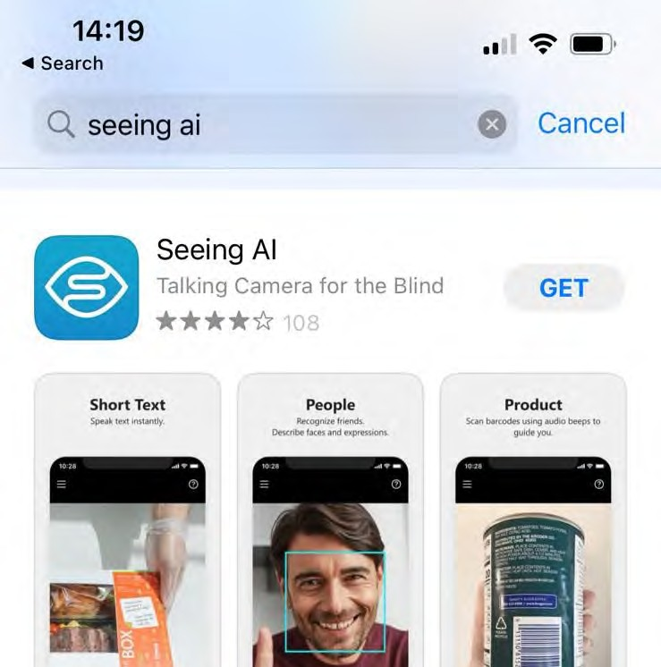Search for the “Seeing AI” icon to use it.

32

People who have an Android smartphone
(such as a Samsung, Huawei, Google Pixel, or Motorolla handset)
App name: Envision Cost: Free
  - Open the “Play Store” programme on your Android smartphone
  - Search for “Envision AI”

  - Press “Install” to download the app

  - Search for the “Envision” icon to use it.

Tips and Tricks

How to check the validity of phone calls from the bank

Ever had that funny feeling when you answer the phone that something isn't quite right? The person on the phone says they’re from the bank…but you’re not sure?
Now you don’t have to ignore that feeling.

There is now an official phone number you can call to verify a phone call from someone who says they’re calling from your bank. The number to call is 159.
When you call 159, you will be connected directly to your bank. 159 works in the same way as 101 for the police, or 111 for the NHS. It’s the number you can trust to get you through to your bank, every time.
159 will never call you. Only a fraudster will object to you calling 159.
Unfortunately, it's becoming increasingly likely that there's a very convincing fraudster on the other end of the phone.
Last year, criminal gangs stole over £470 million by pretending to
be someone’s bank. Many scammers impersonate authority
figures (banks, HMRC, the Police etc) and the scammers are very good at what they do.

Sometimes scammers send false contact details, enticing people to call them. Should you carry on a conversation to confirm your suspicions? No, the best thing to do is hang up and dial 159 straight away.
159 is a collaboration between Lloyds (Royal Bank of Scotland), NatWest Group (Bank of Scotland), Barclays, Santander, Starling and telecommunications firms. It is led by Stop Scams UK and the Global Cyber Alliance. It supports personal, Premier,
credit card and business banking customers.

How to use the 159 phone number:

- If you receive a call claiming to be from your bank,
asking you to take any financial action, such as moving money to a 'safe' account or making a payment, hang up and call 159.

- Let your bank check for you: the 159 system will connect you to your bank who will confirm if the call was genuine.

- 159 will never call you. If you get a call from 159, don't answer the call.

Get Involved

Your feedback would be highly valued

Are you involved in sport? Are you someone that has been involved in sport in the past? Are you unsure of joining any sporting activities in the future?
We would love to hear from anyone that would like to share their
experiences of how they have participated in sport within their local community – the positive experiences but also the barriers that you may face when getting involved.
We realise how important sport is to veterans accessing our services. However due to sight loss, many veterans feel unable to access the same opportunities as before. We are also aware of many veterans who still enjoy full participation in sports whilst living with sight loss. If either of these sound familiar, then we would love to hear from you.
Your feedback and views are valued and would build on our previous Veteran Experience Group work with similar groups.
To get in touch, please call us on 0800 035 6409 and say you would like to contribute to the new Veteran Experience Group.
Alternatively, contact Tom Scott at Sight Scotland Veterans on
07824 873 540 or by email:
tom.scott@sightscotlandveterans.org.uk

Sight Scotland Veterans Update

Our 2022 Winter Grant

As you may know, we are developing our financial wellbeing support so that we can provide tailored, targeted support where it is most needed.
As part of this, we have put a new Winter Grant of £110 in
place for 2022. With rising concerns over the cost of living, this grant is available to help ease any financial hardship you may experience during the winter.
If you are concerned about your finances in the upcoming festive period, you can apply for the grant.

To be eligible, you must be in receipt of at least one of the following benefits:
- Income-based Jobseeker’s Allowance
- Income-related Employment and Support Allowance
- Income Support
- Pension Credit
- Tax Credits (Child Tax Credit and Working Tax Credit)
- Housing Benefit
- Council Tax Support
- Universal Credit

To be eligible for this grant, you must also have joined our organisation, Sight Scotland Veterans, before 1 September 2022.
You can apply for the grant between now and 30 November 2022.
To apply, please call us on 0800 035 6409 and ask about the Winter Grant. We will take your details, confirm whether you are eligible for the grant and, if so, arrange for the payment. Payments will be made in time for Christmas.
Alternatively, if you prefer, you can speak to your Centre Officer or Independent Living Officer about the grant.

News in Brief

Veterans encouraged to share views on the ban on homosexuality in the Armed Forces prior to the
year 2000

Individuals who were affected by the ban on homosexuality in the Armed Forces that was in place prior to the year 2000 are invited to submit their views to an independent review on the policy.

The independent review was announced by the Defence Secretary and former Chancellor of the Duchy of Lancaster Steve Barclay,
as part of the Veterans’ Strategy Action Plan in January 2022.
The independent review seeks the opportunity for the government to better understand the lived experience of LGBT veterans who served between 1967 to 2000, including how being discharged from the military because of their sexuality affects their life.
Family members can also share their experiences and views. The government accepts that this historic policy was wrong.
The government has committed to understanding, acknowledging and, where appropriate, addressing the impact it has had on veterans today, in particular in relation to members of the LGBT community.

The call for evidence contains a number of questions and topics for veterans to offer feedback on.

The Lord Etherton PC QC, who was appointed in June, said: “The object of the Review is to provide evidence-based recommendations to the government as to how best the
government can meet its commitment to ensure that all veterans’ experiences are understood and their military service valued, and how best to acknowledge and remedy the
injustice of dismissal of LGBT service personnel prior to 2000 on the grounds of their sexual orientation.
“I encourage all those affected by the ban to come forward with testimony in this safe environment, to shape the review’s recommendations.”
- If you wish to participate, your Independent Living Worker at Sight Scotland Veterans can assist you.
- You can contribute your views and experiences by posting a submission document in the mail to the independent reviewers. Your Independent Living Worker can arrange for a submission document to be mailed to you.
- Alternatively, you can request a document by email: contact@lgbtveterans.independent-review.uk
Or, you can make a submission online at:
https://www.smartsurvey.co.uk/s/LGBTVeteransReview/
- More information can be found online at:
https://www.gov.uk/government/organisations/lgbt- veterans-independent-review
- Fighting With Pride, the LGBT+ Military Charity, can provides support to those who seek it. You can contact Fighting With Pride online at fightingwithpride.org.uk

Thank you for reading the latest edition of The Bugle.
We promise to keep your information safe and will never sell or swap your details. If you change your mind about receiving newsletters, please email
hello@sightscotlandveterans.org.uk or call 0131229 1456

